Assessment and Homelearning 2026/2027
Subject: ENGLISH
Assessment and Homelearning overview Year 11 English
Assessments this year | Topics to revise | Assessment Details
AP1- October  AP2- February  GCSE – May – June  Weekly quizzes | LANG Paper 2  Sections A Reading and B Writing  LIT Macbeth  LANG Paper 1 Section A Reading Section B Writing  LIT paper: Jekyll and Hyde  Power and Conflict Poetry  Unseen Poetry  Lang Paper 1: analysing fiction & creative writing  Lang Paper 2:  Analysing non-fiction & viewpoint writing  Lit paper 1: Jekyll and Hyde,  Macbeth  Lit paper 2: An Inspector Calls, Power and Conflict Poetry,  Unseen Poetry  Language Paper 1 & 2  Knowledge Organisers: | AP1 Formal assessments  The written exams will last 1 hour and 45 minutes. The English Language exam consists of a READING section /40 marks and WRITING section /40 marks. This will be sat in exam conditions in the hall.  The Literature exam will be in the exam hall (AP1 1 hour 45 mins).  AP2 Formal assessment:  Language papers 1 (1 hour 45 mins)  Literature paper (hybrid) 2 (2 hours 15 minutes)  Final GCSE examinations  You will be set home work to learn sections of your knowledge organiser each week  Your learning will be assessed through weekly quizzes
Key online resources:
GCSE POD/Other online learning platform:
https://members.gcsepod.com/pupils/assignments/assignment/1223986

Knowledge organisers:
Macbeth Knowledge Organiser .pdf

Paper 1 Knowledge Organiser Section A1.pdf
Language paper 1 section B WRITING knowledge organiser.pdf
Paper 2 Knowledge Organiser Section A.pdf
Language Paper 2 section B WRITING Knowledge Organiser.pdf

Free Homework & Revision for A Level, GCSE, KS3 & KS2

 GCSE English Literature - BBC Bitesize

Curriculum information:
In your final year, you will continue to study both English Literature and Language.
You will learn new knowledge: Macbeth
You will also revisit knowledge from Year 10:
Literature: An Inspector Calls, Jekyll & Hyde and Power & Conflict Poetry
Language :
Paper 1 Fiction – reading and writing skills
Paper 2 – non-fiction modern and pre-1914 writing – reading and writing skills

Tier 3 words:
Technique / Definition
Simile : Comparison between two things using like or as.
Metaphor : A way of comparing by saying something is something else, even though it isn’t. Alliteration : The occurrence of the same sound at the beginning of adjacent or closely connected words.
Sibilance : Sibilance is a more specific type of alliteration that relies on the repetition of soft consonant sounds (s).
Onomatopoeia : The use of words to imitate or suggest the sounds that they describe.
Repetition : The use of a word or phrase more than once within a text.
Personification : Providing inanimate objects with human qualities or attributes.
Semantic field : A collection of words which are related through their similar meanings or to a similar topic.
Extended metaphor : A metaphor that isn't just used in one line but is extended over multiple lines or throughout the work.
Imagery : words or lines that evoke or present a very clear image.
Colloquial language : words or phrases that feature informal language that we often use in conversations.
Rhetorical Question : A question that aims to challenge the listener or stimulate thought
Symbolism : The use of symbols to represent ideas or qualities.
Plosives : A consonant that is produced by stopping the airflow using the lips, teeth, or palate, followed by a sudden release of air. The sounds that are generally associated with the letters p, t, k, b, d, g.
Characterisation : the methods the writer uses to create or construct a fictional character
Reveal : exposure to the reader or audience of a previously unseen key character, or element of plot or performance

Please be aware - Class teachers will set additional activities to support their learning. This will include research, completing written tasks or preparing for in-class assessments.

week: | Date: | Knowledge retrieval task | Activity/ Help resource
1-6 | 1/9 – 11/10/26 | Home learning booklets – language and Macbeth | Macbeth_First_Letter_Revision (3).docx  Year_11_Macbeth_Theme_Flashcards (3).docx  Year_11_English_Language_Paper_2_AP1_Revision_2026 (3).docx
7 | 12/10/2026 | Exam week - revise for exams
8 | 19/10/2026 | Exam week – revise for exams
 |  | HALF TERM - revision
9 | 2/11/2026 | P&C Poetry: Remains & Exposure | Knowledge Organiser  Flash cards Power and Conflict Poetry Knowledge Organiser.pdf
10 | 9/11/2026 | P&C Poetry: Remains & Exposure  P&C Poetry: War Photographer & Prelude | KO req
 |  |  | Power and Conflict Poetry Knowledge Organiser.pdf
 |  |  | Create flashcards for key quotes
11 | 16/11/2026 | P&C Poetry: War Photographer & Prelude  P&C Poetry: Poppies & Charge of the Light Brigade | KO req
Power and Conflict Poetry Knowledge Organiser.pdf
Create flashcards for key quotes
12 | 24/11/2026 | P&C Poetry: Emigree, Kamikazee & London | KO req  Power and Conflict Poetry Knowledge Organiser.pdf
 |  | P&C Poetry: Emigree, Kamikazee & London | Create flashcards for key quotes
13 | 30/11/2026 | P&C Poetry: Checkin out Me History, Kamikazee & Ozymandias | KO req Create flashcards for key quotes
 |  | P&C Poetry: Checkin out Me History, Kamikazee & Ozymandias | Power and Conflict Poetry Knowledge Organiser.pdf
14 | 7/12/2026 | Christmas Break - Revise ALL knowledge from the Language paper 2 and Poetry knowledge organisers | KO req Create flashcards for key quotes  Power and Conflict Poetry Knowledge Organiser.pdf
15 | 14/12/2026 | Learning from this KO was previously set Summer year 10.  Revisit Jekyll and Hyde chapters 1 2 3 & 4 –  Context : 1. The Victorian Era / 1. Victorian Values / 1.The Impact of Industrialisation on Society.  2. Victorian London / 2. The Gothic Story / 2. Freud  Quotation Cards: Chapter 1, 2 & 3  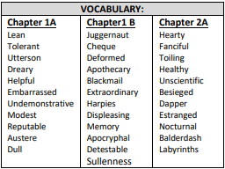  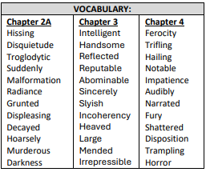 | KO req Create flashcards for key quotes  Jekyll and Hyde Knowledge Organiser.pdf
16 | 4/1/2027 | Jekyll and Hyde chapters 5, 6 & 7  Quotation Cards: Chapter 4, 5 6 7 & 8  Jekyll and Hyde chapters 8&9  Context : 3. Key Characters / 3. Key themes 3. 4. Historical Context / 4. Fear of scientific progress /  4. Context: Physiognomy  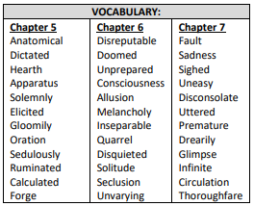  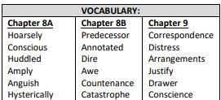  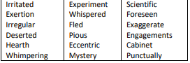 | Jekyll and Hyde Knowledge Organiser.pdf  Knowledge Organiser  Flash cards
17 | 11/1/2027 | Jekyll and Hyde chapters 8&9  Context : 5. Biblical and classical allusions  Quotation Cards: Chapter 9 & 10  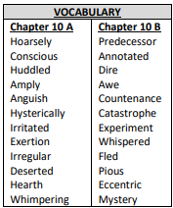 | Jekyll and Hyde Knowledge Organiser.pdf  Knowledge Organiser  Flash cards
18 | 18/1/2027 | Exam week - revise for exams  AP2 revision –  Language: Paper 1  Literature: Jekyll and Hyde, Power and Conflict Poetry, Unseen Poetry | Jekyll and Hyde Knowledge Organiser.pdf  Knowledge Organiser  Flash cards
19 | 25/1/2026 | Exam week - revise for exams  AP2 revision –  Language: Paper 1  Literature: Jekyll and Hyde, Power and Conflict Poetry, Unseen Poetry | Jekyll and Hyde Knowledge Organiser.pdf  Knowledge Organiser  Flash cards
20 | 1/2/2026 | Exam week - revise for exams  AP2 revision –  Language: Paper 1  Literature: Jekyll and Hyde, Power and Conflict Poetry, Unseen Poetry | Jekyll and Hyde Knowledge Organiser.pdf  Knowledge Organiser  Flash cards
21 | 8/2/2026 | Exam week - revise for exams  AP2 revision –  Language: Paper 1  Literature: Jekyll and Hyde, Power and Conflict Poetry, Unseen Poetry | Jekyll and Hyde Knowledge Organiser.pdf  Knowledge Organiser  Flash cards

