

Year 9

Options Choices Booklet

2026-2028

Fulwood Academy



This booklet is designed to provide clear and helpful information about the options process at Fulwood Academy, enabling pupils and parents/carers to make informed, thoughtful and ambitious choices about Key Stage 4 study. It explains how the options process works and provides detailed information about the courses available.

What will pupils study at Key Stage 4?
At Fulwood Academy, we are committed to providing every pupil with a broad, balanced and ambitious curriculum. Our curriculum is designed to promote strong knowledge, develop high levels of literacy and numeracy, and ensure pupils leave school as confident, well-rounded young people who are well prepared for their next steps.

All pupils follow a shared curriculum entitlement that:
- Keeps future pathways open
- Avoids unnecessary early narrowing
- Provides appropriate challenge and support for all learners
- Prepares pupils for further education, apprenticeships and employment

English Language, English Literature, Mathematics and Science are compulsory subjects studied by all pupils until the end of Year 11, with pupils achieving at least one GCSE in each. In addition, all pupils take part in Core Physical Education and Religious Education.

Alongside these compulsory subjects, pupils are given the opportunity to specialise and personalise part of their curriculum by selecting four option subjects, allowing them to pursue interests, strengths and future aspirations while maintaining a broad academic foundation.

Introduction
Pupils are required to select four option subjects which, alongside the compulsory curriculum, will form their programme of study at Key Stage 4. Subjects not chosen will no longer be studied beyond Year 9.

We offer a wide range of academic, creative, practical and applied subjects, with varied assessment methods and clear progression routes beyond Year 11. When making choices, pupils should consider:
- The content of the course
- How it is taught and assessed
- The skills it develops
- How it supports future study or career pathways

All courses offered are high-quality, nationally recognised qualifications designed to support progression to further education, training or apprenticeships.

To ensure pupils make choices that enable them to be successful, the school provides carefully structured guidance and support throughout the options process. This includes assemblies, personal development sessions and opportunities for discussion with staff. Guidance is individualised, taking account of pupils’ strengths, interests and support needs, while maintaining high expectations for all.

Curriculum Entitlement and Inclusion
Fulwood Academy is committed to ensuring that all pupils, including those with special educational needs and/or disabilities (SEND) and those who are disadvantaged, have equitable access to a broad and ambitious curriculum.

Options guidance is personalised and supportive, and reasonable adjustments are made within subjects to enable pupils to thrive. Decisions are made in partnership with pupils and parents/carers to ensure choices are aspirational, appropriate and lead to successful outcomes.

What is the English Baccalaureate (EBacc)?
The English Baccalaureate (EBacc) is a group of GCSE subjects identified by the Government as promoting strong academic foundations and powerful knowledge. It is not a qualification in itself, but recognises pupils who achieve Grade 5 or above in:
- English
- Mathematics
- Science
- A language
- History or Geography

Why is the EBacc a consideration in options choices?
Research indicates that studying the EBacc subject combination can support strong outcomes across a wide range of subjects, due to the high-level literacy, numeracy and transferable skills developed. These subjects help keep future education and employment pathways open and are viewed favourably by many universities and employers.

The Government’s ambition is for an increasing proportion of pupils nationally to study the EBacc suite. While the EBacc may be a strong choice for many pupils, it is not the right pathway for everyone, and pupils are supported to make choices that best suit their individual strengths and aspirations.

How does Fulwood Academy’s curriculum support the EBacc?
Our Key Stage 3 curriculum is carefully sequenced to provide a strong foundation in EBacc subjects, ensuring that all pupils are well prepared to access these GCSE courses with confidence should they choose to do so.

The English Baccalaureate and Options Guidance
During the Year 9 options process, pupils receive guidance and recommendations to help them choose a curriculum that is ambitious, balanced and appropriate for them. All pupils study English Language and Literature, Mathematics, Science and a humanities subject, and are supported in deciding whether a language GCSE forms part of their Key Stage 4 curriculum.

Guidance is based on a range of factors, including prior attainment, strengths, interests and future aspirations. Importantly, options are not about labelling pupils, but about ensuring every pupil has the opportunity to succeed within a curriculum that challenges and supports them appropriately.

Options Selection
Pupils select one subject from each option block, along with a reserve choice for each block. Reserve choices are required to ensure pupils can still be allocated a suitable subject should a course be unable to run due to low uptake.
All courses are offered in good faith, but availability depends on sufficient demand and staffing capacity. Where necessary, pupils and parents/carers will be supported to identify suitable alternatives.

Option block A ​ | Option block B ​ | Option block C | Option block D ​
Geography ​  Spanish  History  Triple Science  Imedia  Art & Design: Art, Craft & Design ​  Art & Design: Photography ​  Business Studies | Spanish  History ​  Statistics (Maths)  Geography ​  Computer Science  Health and Fitness (Sport)(NCFE) ​  Hospitality & Catering (WJEC) ​  Religious Studies ​ | Geography ​  History ​  Religious Studies ​  Drama ​  Imedia  Triple Science  Statistics (Maths)  French | Art & Design: Art, Craft & Design ​  Art & Design: Photography ​  Art & Design: Textiles ​  Imedia  Hospitality & Catering (WJEC) ​  Health and Fitness (Sport)(NCFE) ​  Music  Business Studies

*Please note that all courses are offered in good faith; however, a course will only run where there is sufficient pupil uptake. In order to provide the greatest possible number of pupils with one of their preferred choices, the school reserves the right to adjust option blocks or reposition subjects where this allows us to meet demand more effectively.*

What is the difference between a GCSE and a Technical Award (BTEC or Cambridge National)?
GCSEs and Technical Awards are equally valued Level 2 qualifications, but they differ in the way pupils are assessed and the experiences they provide.
GCSE qualifications are primarily exam-based and focus on developing subject knowledge alongside analytical, evaluative and written skills. All GCSE examinations take place at the end of Year 11 and are assessed using the 9–1 grading system (with 9 being the highest grade). GCSE English also includes a Spoken Language assessment, which contributes to the non-examined assessment element of the course.
Technical Awards, such as BTEC and Cambridge National qualifications, are also equivalent to one GCSE and are designed to combine academic knowledge with practical, applied learning. These courses are often linked to real-life contexts and industries, helping pupils to understand how their learning connects to the world of work and future careers.
All Technical Award qualifications include an externally assessed examination unit, which accounts for at least 40% of the overall qualification. This examination may be taken at the end of Year 11 or, in some cases, earlier in the course. The remaining units are internally assessed, usually through structured coursework assignments completed throughout the two-year programme of study.
Technical Awards are graded using a scale from Level 1 Pass up to Level 2 Distinction*.
Both GCSEs and Technical Awards support progression to post-16 education, apprenticeships and employment, and pupils are guided to choose the type of qualification that best suits their learning style, strengths and future aspirations.

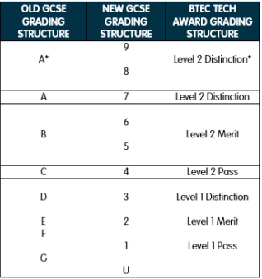

If pupils or parents/carers require any further information or clarification regarding the options process or individual courses, please contact Mrs Dixon (Mr. Nockels), Head of Year 9, who will be happy to provide support and guidance.
There are a range of sources of help and advice available to pupils when making their option choices. Different people may offer guidance from different perspectives, including subject teachers, tutors, parents/carers and pastoral staff. It is important that pupils consider this advice carefully and reflect on how it applies to their own strengths, interests and future aspirations when making final decisions.

Dos and Don’ts for pupils
All pupils will attend a year group assembly where the options process will be introduced and clearly explained. Pupils have also taken part in Personal Development sessions outlining the subjects available at Key Stage 4. Information about each course has been produced by subject specialist Directors of Learning to ensure accuracy and clarity.
The school will also host a Parents’ Options Evening on Thursday 26th February, where pupils and parents/carers will have the opportunity to meet subject teachers on a one-to-one basis. This will allow families to discuss pupil progress, course content and assessment, and to ask any questions needed to support pupils in making confident and well-informed choices.

DO
- DO choose subjects that interest you and suit your strengths and aspirations. You are the person who will be studying these courses over the next two years.
- DO choose subjects that you enjoy and are motivated to work hard in.
- DO talk to your tutors, subject teachers and parents/carers to seek advice and guidance — they are there to support you.
- DO consider your future plans beyond Year 11, including further education, apprenticeships and career pathways.
- DO challenge yourself. Do not avoid a subject you enjoy simply because it may feel demanding — with commitment and support, you may be surprised at what you can achieve.

DON’T
- DON’T choose a subject simply because your friends have chosen it. You may have different interests or future plans, and there is no guarantee you will be placed in the same class.
- DON’T choose a subject based solely on your current teacher, as staffing may change at Key Stage 4.
- DON’T choose a subject just for a change without fully understanding what it involves. Once courses begin, changes are not usually possible.
- DON’T make final option choices without reading and understanding the information in this booklet and, where possible, attending the Parents’ Options Evening.

Submitting options choices
After attending the Parents’ Options Evening, pupils and parents/carers will have the opportunity to reflect on and discuss the most appropriate course choices before submitting preferences.
Option choices should be submitted using the options form attached to the back of this booklet. If this is misplaced, replacement copies can be collected from the main reception.
Completed option forms must be returned no later than Thursday 5th March.
Any pupil who has not submitted their choices by this deadline will be supported in school to make appropriate selections. However, they may need to choose from a reduced range of subjects, as priority will be given to pupils who submit their preferences on time.
What happens after Thursday 5th March?
Once all option choices have been submitted, they will be collated and carefully analysed. Pupils will then be allocated to option groups.
Courses that are significantly undersubscribed (typically fewer than 15 pupils) are unlikely to run, and in these cases reserve choices will be used. It may take several weeks after Easter for option allocations to be finalised.
Parents/carers and pupils will be informed of the subjects that have been allocated once the process is complete.

How should pupils and parents/carers use this booklet?
This booklet is intended to provide clear information about the options process and the subjects available. However, it should be used alongside discussions at the Parents’ Options Evening, where subject teachers can offer further insight into course content, assessment and expectations.
Pupils are encouraged to use this booklet as a starting point for exploring potential subjects, considering the following questions:
- Does the subject sound like one I would enjoy studying?
- Does it suit my strengths and learning style?
- Will it support my future plans, including sixth form, college, apprenticeships or employment?
Parents/carers are encouraged to use this booklet to support meaningful conversations with pupils, helping them to make informed and well-reasoned decisions about their Key Stage 4 curriculum.

Are courses within each option block guaranteed to run?
All courses listed are offered in good faith; however, the school has a finite number of staff, specialist resources and teaching spaces. As a result, a course will only run if there is sufficient demand from pupils. In most cases, courses with fewer than 15 pupils are unlikely to run.
To provide the best possible combination of subjects for the greatest number of pupils, the school may:
- Move subjects between option blocks
- Combine courses offered in more than one block
- Use pupils’ reserve choices where necessary
Where a course is oversubscribed, the school will endeavour to provide additional classes to meet demand. In rare circumstances where this is not possible due to specialist staffing or facilities, some pupils may be guided towards their reserve choice. In all cases, pupils and parents/carers will be supported throughout the process.

Frequently asked questions
Do pupils have to make a reserve choice?
Yes. Pupils are required to select a reserve choice in each option block. This is because there is a possibility that a first-choice course may not run due to levels of demand or staffing capacity.
If a course is unable to run, pupils will be allocated to their reserve choice, so it is important that this is a subject they would be happy to study. Pupils who do not select a reserve choice will be supported to make an alternative selection if required; however, this may be from a more limited range of subjects, as priority is given to pupils who have completed all required choices.
Will pupils definitely get their first or reserve choice?
Our aim is always to allocate pupils to one of their preferred choices, and in the vast majority of cases this is achieved.
In rare or exceptional circumstances where this is not possible, the school will communicate directly with pupils and parents/carers to explain the situation and work together to identify a suitable alternative. Pupils will be fully supported throughout this process.
When is the deadline for submitting the final options form?
All completed options forms must be submitted by Thursday 5th March 2025.
Some options subjects are new. How do I know whether to choose them?
A small number of subjects may not have been studied during Key Stage 3. Information about these courses is provided within this booklet, and further guidance is available during the Parents’ Options Evening.
At the Options Evening, pupils and parents/carers will have the opportunity to speak directly with subject teachers to ask questions about course content, assessment and expectations, ensuring pupils can make well-informed decisions.

Can pupils switch courses if they change their mind at a later time?
Once a course has begun, pupils are not normally able to change subjects unless there is a medical reason that means they can no longer access the course.
This is because all course content contributes towards the final GCSE or Technical Award assessment, and joining a course late would place pupils at a significant disadvantage. It is therefore very important that pupils take time to consider their choices carefully and make full use of the information and guidance available before submitting their final options.
Can the same subject be selected twice?
No. Each subject can only be studied once, as awarding bodies allow only one qualification per subject. Pupils must therefore select different subjects from each option block.

Year 9

Options
2026-2028

Compulsory Subjects with a
Qualification




All students in Years 10 and 11 will take the following subjects which lead to a qualification:

- English Language (GCSE)
- English Literature (GCSE)
- Mathematics (GCSE)
- Combined Science (GCSE) or
- Triple Science (GCSE) if is selected as an option

GCSE English

ENGLISH LANGUAGE AND LITERATURE


This subject will suit you if:

- If you have an appetite for reading, enjoy writing creatively and delivering speeches, then this course will suit you.



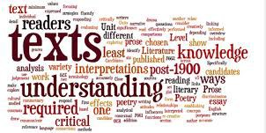
What will the course involve?
Why is English compulsory at Fulwood Academy?
English is an exciting, interesting and relevant subject for any student to study; the skills you learn in English are transferrable to real life situations every day.

In the modern world, good communication skills are essential. From understanding letters and mail, to creating presentations within our jobs, to writing correspondence to companies, and entering into contractual agreements. Without a doubt the analytical, evaluative and communicative skills you learn in English are vital to your future lives.

All of the teachers in the English department are passionate about the subject. We love words and language, novels and poetry, but most importantly, we love helping young people to unleash their analytical skills and creative potential.

We will make you work hard. We will expect the highest of standards and only your very best effort. We will ensure your future success in this subject.

English Language
The syllabus followed will be AQA which is split into two examination components. You will be required to read extracts and answer a range of questions on each extract. Additionally, you will have to produce both a non-fiction and fictional piece of writing.

However, that is just the exam. What we want is for you to have an appreciation for written works. We would look for you to be able to analyse language effects and enthusiastically engage in meaningful discussions about how texts are written and the effects they achieve. Our desire is for our students to write imaginatively and confidently for a range of situations and scenarios.

How will I be assessed?
Two examinations and a Spoken Language assessment.

English Literature
All students will follow GCSE English literature. The syllabus followed will be AQA which is split into two examinations.
Where does the course lead?
English GCSE opens up many avenues for the future. You could go on to study English language and literature at A Level. With English A Levels under your belt, the options are limitless with jobs in publishing, news & sport journalism, travel writing and teaching, to name but a few.

Within literature we will explore a range of texts in a variety of literary formats. Through the study of this subject, not only is it important for us to sharpen students’ analytical skills, but also to develop and inspire a love and passion for reading. We will have lots of in-depth, exciting discussions and debates where we form meaningful opinions and interpretations about what we have read and develop our analytical skills in preparation for the exam.

How will I be assessed?

Two examinations

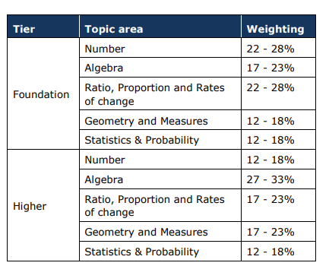

Where does the course lead?

Mathematics is a vital part
of everyday life. As well as the obvious uses of numbers there are a variety of careers that insist on mathematics qualifications e.g. engineering, architecture and medicine at A Level.

What will the course involve?
The course has been designed to increase the level of challenge at GCSE level. The syllabus builds upon prior learning of mathematics at Key Stage 3. All aspects of numeracy and functional mathematics are taught in a variety of methods, including group work, independent learning and traditional styles. You will be encouraged to explore the mathematics that surround you in everyday life as well as the techniques that you will use throughout your working life and careers. You will encounter topics that you have studied previously alongside other areas of mathematics such as trigonometry and vectors.

How will I be assessed?
The assessments will cover the following content headings:
1 Number
2 Algebra
3 Ratio, proportion and rates of change
4 Geometry and measures
5 Probability
6 Statistics
- Two tiers are available: Foundation and Higher (content is defined for each tier).
- Each student is permitted to take assessments in either the Foundation tier or Higher tier.
- The qualification consists of three equally weighted written examination papers at either Foundation tier or Higher tier.
- Paper 1 is a non-calculator assessment, and a calculator is allowed for Paper 2 and Paper 3.
- Each paper is 1 hour and 30 minutes long.
- Each paper has 80 marks.
- The content outlined for each tier will be assessed across all three papers.
- Each paper will cover all Assessment Objectives, in the percentages outlined for each tier.
- Each paper has a range of question types; some questions will be set in both mathematical and non-mathematical contexts

How will I be prepared for the examinations?
The department uses exam questions to form examinations which will be graded, and question level analysis will be shared so the pupil knows where their strengths and area for development are. Individualised homework will be issued weekly on Sparx Maths and weekly Sparx Insights will allow staff to address misconceptions from the homework. Students will be entered for Higher or Foundation Tier based on their performance in homework and in class assessments.
This subject will suit you if:

- You push and challenge yourself;
- You are able to work independently and pro-actively;
- You seek to understand the world around you in more depth.
Why is Mathematics compulsory at
Fulwood Academy?
The Mathematics department at Fulwood Academy is central to ensuring students achieve the best possible outcomes and levels of progress at GCSE level.

Students follow a course suitable to their ability in sets so that they are challenged to work at a level that will stimulate and engage them.

Regular assessments provide milestones so that progress is tangible and engenders an understanding and appreciation of the mathematics that will surround them throughout their lives.
GCSE Mathematics
MATHEMATICS


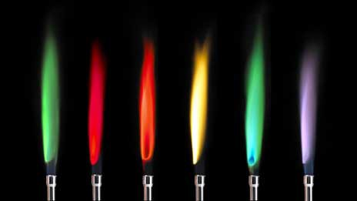

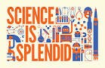
Why is Science compulsory at Fulwood Academy?
We believe that science has something to offer every student. From a trainee chef to a nuclear physicist, a construction apprentice to a cancer researcher, everyone needs some level of relevant science understanding. From the natural world to modern technology, science exists all around. Understanding science basics and learning the scientific process helps us figure out how things work. Understanding how the world works builds a foundation for learning so students can comprehend advanced ideas. The knowledge also helps older students and adults improve the world, protect natural resources and even create new products or solutions for problems in the world. The scientific process engages critical thinking through developing questions, creating hypotheses, conducting experiments and evaluating the data collected. The scientific process also encourages problem-solving that students can apply to real life.
GCSE Science
COMBINED SCIENCE
.



Combined Science – What does the course involve?
Combined science involves studying for two GCSE qualifications.
You’ll explore exciting topics in biology, chemistry and physics and sit six exams – gaining the equivalent of two GCSEs.
It’s excellent preparation if you want to study science after Key Stage 4.
Students are assessed by examinations at the end of Year 11.

Triple Science – What is the difference? Who is it for?
Triple science involves studying for three GCSE qualifications – biology, chemistry and physics. Students will get a separate grade for each subject. If you are really interested in science and want to study it in college it will be a great start as you cover more of each science. You need to be good at science and motivated to meet the challenges of triple. It is all assessed by exams at the end of Year 11.


This subject will suit you if:

- You enjoy the challenge of science and investigative work;
- You want to go on to study a science at A Level.

What do the courses lead to?
Students with high attainment can progress to A Level Science study following their GCSEs. Other vocational courses are available depending on your interests and goals.
How will I be assessed?
All GCSEs are now linear rather than modular. This means all exams will take place at the end of the course. There will be no controlled assessment, although practical lessons will help you answer questions in the exams. The course is assessed by examination at the end of the two year course.

Compulsory Subjects without a Qualification


All pupils in Years 10 and 11 will take the following subjects which do not gain a formal qualification:

- Physical Education (Core)
- Religious (Core)
- Personal Development (Personal, Social, Health and Economic Education)



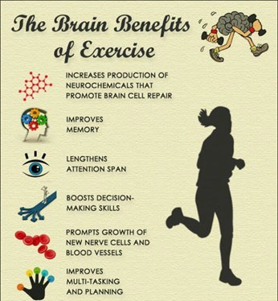
How can core PE help my other studies?
PE has a variety of cross curricular links. It includes opportunities for pupils to discuss the importance and impact of being active and how to look after their bodies. This will link across with Health and Social, Science, Social Science, Food Technology and other additional formal and informal opportunities throughout the year such as Sports Relief and other charity events. There are physical, mental and social benefits associated with physical exercise that contribute to your overall health and wellbeing and helps make you a better learner.
What will core PE involve?

One weekly physical exercise lesson per week that builds upon previous learning from sport and exercise studied in KS3. Each lesson will have an emphasis on maximum engagement and maximum enjoyment to help promote lifelong learning and lifelong participation. The sports studied include:

Football, Netball, Basketball, Rugby, Badminton, Fitness, Handball, Dodgeball, Dance, Rounders, Cricket, Softball and Athletics.
Why do all Year 10 and 11 pupils study Core PE at Fulwood Academy?
High quality PE and sport enthuse ALL pupils to develop a healthy lifestyle and strong core skills of cognitive and social development for now and their whole lifetime. Wide ranging opportunities in core and more diverse sports lead pupils of all abilities to find a personal love and passion for activity which can shape their future lives. Everyone is educated and enthused to develop a healthy lifestyle for now and their whole lifetime. The school community develop a positive attitude to sport, based around the WE CARE, WE CHALLENGE, WE COMMIT values of the academy, to help when winning, losing or simply participating, with an emphasis on character building.
Regular, high-quality PE sessions allow all pupils, irrespective of their level of ability, to develop core skills in a range of physical activities. All pupils develop a love of sport which they enjoy and excel in, the curriculum is extensive and varied to cater for the wider community of the academy who have different interests and investments in certain sports and physical activities. Gifted and talented pupils are recognised and supported in being challenged to excel. Opportunity is given to access local sports through our extensive extra-curricular programme, which can provide lifelong hobbies and help pupils to improve their motor competence, knowledge of rules and improve their Health.
CORE PE

Physical Education (Core)

Core Subject
Personal Development



Personal Development lessons at Fulwood Academy provide pupils with the opportunity to increase their understanding of key issues facing them in the world beyond Fulwood. This includes building upon the health and wellbeing education at KS3 and exploring topics around post 16 options, employability and finance education. Personal Development is a core non-examined subject at Fulwood Academy and pupils will receive 2 lessons per fortnight in Years 10 and 11



What will the course involve?
The topics currently covered at Key Stage 4 in Personal Development are –

- Relationship and Sex Education (RSE) – building upon KS3 learning and embedding important concepts.
- Taking Responsibility for My Own Health – focussing on both physical and mental health.
- Employability – planning for future careers
- Finances Education – developing and understanding of financial products, budgeting and financial ethics
- Study Skills – developing revision techniques and exploring ways to manage mental health and well- being throughout KS4 and beyond
- Preparation for Post 16 – Providing pupils with information about choices post 16 and an opportunity to complete college/apprenticeship applications and create CV’s.
The curriculum is subject to change based on the needs of pupils throughout the year.

How will I be assessed?
Although Personal Development is a non-qualification subject, pupils will still be assessed on the knowledge they have gained throughout the topics studied to check for understanding and will also be expected to engage fully in group discussions and complete all work set.

Option Subjects


All pupils in Years 10 and 11 will select 4 of the following options.
Computer Science | GCSE
Spanish/French | GCSE
Geography | GCSE
History | GCSE
Triple Science | GCSE
Art & Design: Art, Craft & Design | GCSE
Art & Design: Photography | GCSE
Art & Design: Textiles | GCSE
Creative Imedia | GCSE VOC
Drama | GCSE
Hospitality & Catering | WJEC VOC
Digital Information Technology | GCSE VOC
Religious Studies | GCSE
Health and Fitness (Sport) | VCERT
Music | GCSE
Statistics | GCSE
Business Studies | GCSE VOC
Travel and Tourism | GCSE VOC

GCSE Computer Science





GCSE Computer Science

Why choose the GCSE in Computer Science?

In an ever-revolving digital world, jobs in Computing are fast becoming well paid careers. This exciting course is an engaging qualification that will equip you with the knowledge and practical skills to thrive in the fast-changing world of Computer Science.

This qualification provides a practical approach to developing computational skills such as understanding how computers work, to creating programs using code. This Includes innovative, practical onscreen assessment to ensure you can develop the computational skills you will need for an exciting digital future beyond the classroom.
Where does the course lead?
This qualification is for you if you want to start a career in Computing. Achieving this qualification will give you an advantage when applying for a job as a Programmer, Network Manager, Project Manager or any other job that relies heavily on using technology.

This qualification also gives you a sound basis to progress from this qualification to:

Further studies, for example A Levels and Degree Levels or employment where further training may be available.

This subject will suit you if:
- Students will only be allowed to take Computer Science if they are in set 1 for maths. Although, students in other sets may be considered for the course if they have a 6+ and/or can demonstrate an interest in and enthusiasm for the subject and have some experience of programming. Otherwise an alternative option would be Creative iMedia or BTEC information technology.
- You are interested in how computers work and the logical understanding behind them
- You enjoy learning new skills such as programming
- You enjoy Mathematical logic and problem solving
- You are curious to find out information about the awareness of emerging trends in computing technologies, you want to know how computers are put together and want to build one yourself!
What will the course involve?
In order to become proficient computer scientist, it is essential that you have knowledge and understanding of the field’s fundamental principles and concepts.
Therefore the qualification is 100% exam based. With 20 hours experience in programming activities. The qualification has a straightforward structure with six comprehensive topic areas, assessed through two externally-examined papers. One of these is a written paper focused on computational thinking, data, computers, networks, and issues and impacts of computing in the world today. The other is a practical onscreen assessment, which focuses on the ability to analyse and solve problems by designing, writing, testing and refining programs.

How will I be assessed?
Unit  Number | Unit Title | Type | How  Assessed?
 | Units
ICP2/01 | Written examination: 1 hour and 30 minutes 50% of the qualification  75 marks (Principles of Computer Science) | Mandatory | External
ICP2/02 | Onscreen programming examination: 2 hours 50% of the qualification  75 marks (Application of Computational Thinking) | Mandatory | External
Ext 03 | Programming Project 20 hours (Does not count towards final grade but it is a requirement of the course) | Mandatory | Internal

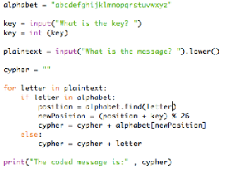

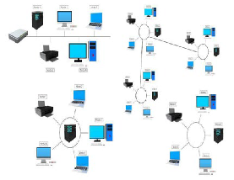


GCSE Languages
Modern Foreign Languages
-
Why choose Languages at Fulwood Academy?

The modern languages department at Fulwood Academy is dedicated to encouraging our students to foster a passion for language learning and develop a curiosity for other cultures and traditions. We are committed to enabling our students to achieve the best possible grades at GCSE level but also to prepare students for studying a language at A Level.
Spanish is the second most spoken language in the world. It is not only spoken in Spain but also in most of South America. Many people in north America also speak Spanish in their homes. The ability to be able to communicate in Spanish would be an advantage in jobs in travel and tourism, teaching, construction, and many other industries.
French is also widely spoken across the world, in Canada and many parts of Africa. As so much business is done on an international level, companies are always on the lookout for employees who can easily converse with overseas colleagues. The ability to be able to communicate in French would put you at a significant advantage.
In opting to study a modern foreign language, you would be able to communicate more confidently and accurately with Spanish or French speakers and you would learn more about the lifestyle and culture of some Spanish or French speaking countries. Foreign language skills are also essential for many jobs in global businesses such as computing, marketing, and finance.



These subjects will suit you if:

- You enjoy communicating with people and discovering how other people live.

- You enjoy working with others to improve your speaking, listening, reading and writing in Spanish.
How is the course assessed?
Paper 1: Listening- Listening comprehension and dictation task. Examination. 25%
Paper 2: Speaking- Role play, reading aloud task and discussion of two photo cards. Examination. 25%
Paper 3: Reading- Reading comprehension and translation task (Spanish-English) / (French-English) Examination. 25%
Paper 4: Writing-Description of a photo in five short sentences, a 40-word written task, translation task from (English-Spanish) / (English-French) and a 90-word written task. Examination. 25%

What will I study?
This is the new specification GCSE Spanish and French examination.

During the course, the students will develop the four main skills: listening, speaking, reading, and writing. Students will be entered for either foundation or higher tiers in listening, speaking, reading, and writing.
We will cover a full range of topics across the following three themes:
Theme 1 - People and lifestyle
Theme 2 – Popular Culture
Theme 3 – Communication and the world around us
GCSE Spanish and French focuses on communication and emphasises the importance of understanding and communicating in everyday situations. You will also study aspects of Spanish or French grammar, translation and phonetics.
Where does the course lead?
Being able to speak a foreign language is now an essential life skill, whether at work, in education or for leisure purposes. Most employers will look more favourably on job applicants with a foreign language and careers include interpreter, translator, lawyer, doctor, nurse, air hostess, import/export industry, engineering, sales and marketing, accountant, secretary, teacher, banking, United Nations, European Union – in fact any career will be enhanced with a language qualification. Further study could be A Level Spanish (Grade 6 is usually a requirement). Many universities now request that students have studied a language at GCSE (particularly some English courses).

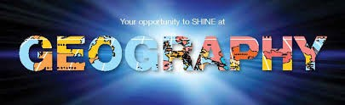
Why choose Geography at Fulwood Academy?
“The world is full of wonders, but they become more wonderful, not less wonderful when science looks at them" – Sir David Attenborough

Geography prepares you for the world of work. The wide range of skills learnt will make any student highly employable!

The geography department is dedicated to helping students achieve the best possible grades, with enjoyable and stimulating lessons through to accessible revision classes.

We hope the study of geography will stimulate an interest into this complex and ever changing world!
This subject will suit you if:
- You are a good communicator and want the opportunity to develop your communication skills, graphical and cartographical skills, technological skills, including ICT and GIS, interpersonal skills through debate and discussion, literacy and numeracy skills, problem solving skills, entrepreneurial skills and awareness of career possibilities.
- You are an independent learner interested in how we interact with the planet and gaining an appreciation of the world around us.
- You are interested in developing enriching your sense of place and finding out more about physical and human geography.
GCSE Geography
GEOGRAPHY

Where does the course lead?

Geographers enter a very wide range of career areas and put simply there is no such thing as a geography job; there are jobs that geographers do. Studying geography provides you with valuable skills and a firm base for life-long learning.

Geography is an entry point to many careers, for example: town and transport planning, chartered surveying, land and water management, sustainability, environmental consultancy, development, tourism, conservation, demography, housing and social welfare.

Employers seek a mixture of skills, qualifications and experience when they recruit for a job. As a geographer you will be in demand as you will be a good communicator, have competent I.T. skills, be an independent researcher, able to work effectively in a team and be able to combine information from a variety of sources.


What will the course involve?
AQA GCSE 8035 Syllabus A new specification

Topics covered over the course include;
- Volcanoes and earthquakes, extreme weather, climate change, tropical rainforests, hot deserts, rivers and coasts.
- Urban issues, development, changes to the U.K. economy and resource management (food, water and energy).
- There will also be two fieldwork investigations involving 2 days outside of school.

How will I be assessed?

Unit 1: Living with the physical environment. 1 hour 30 mins – 35%

Unit 2: Challenges of the human environment. 1 hour 30 mins– 35%

Unit 3: Geographical application and geographical skills 1 hour 15 mins – 30%



the course involve?
GCSE History
HISTORY
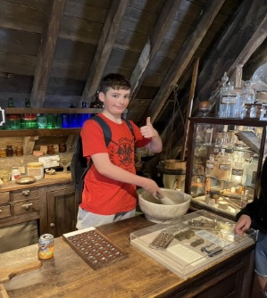
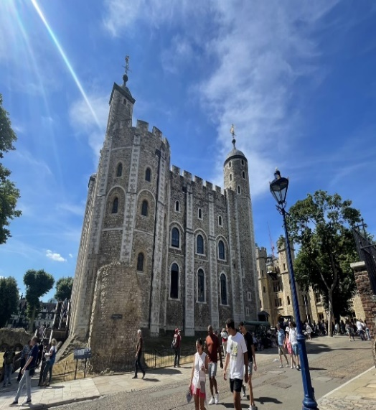
This subject will suit you if:

You can think for yourself, then this may be the subject for you
You are dedicated and committed to your studies, then history is a good choice. There is no denying history is a demanding subject, but that is what makes it worthwhile

What will the course involve?
You will follow the AQA specification. Topics studied include: ‘Medicine Through Time’, ‘Norman England 1065-1100, ‘Conflict and Tension 1918-1939, and ‘Democracy and Dictatorship Germany 1890 - 1945’

How will I be assessed?

100% Examination - You will have three examinations at the end of Year 11.
Paper 1 lasts 2 hours and is a ‘Depth Study and contains two modules on Germany 1890 – 1945 & Conflict and Tension 1918 – 1939.
Paper 2 lasts 1 hour 45 minutes and is a ‘Thematic Study of Medicine Through Time & a historic environmental study on Norman England 1065 – 1100.

Skills needed for these examinations are describing historical features, assessing the usefulness of sources, examining similarity and difference over time and the process of change, making a judgment, cause and consequence and significance.

All students take the same examination papers and can achieve any grade from 1 - 9. History is a written subject that requires you write extended answers and essays. You will be taught how to write appropriately structured and detailed answers and will receive marks for good standards of spelling, punctuation and grammar.

Where does the
course lead?
History at GCSE opens up A Level courses in subjects such as English, law, media, psychology, sociology, politics and philosophy. In terms of university, history is a facilitating subject that has strong links to archaeology, law, English literature, economics, journalism, education, politics and even medicine. Studying history can lead to careers in all of these areas.
Why choose History at
Fulwood Academy?
The history department at Fulwood
prides itself in having skillful, passionate practitioners whose main goal is to guide students to success at GCSE. History is an enjoyable yet rigorous academic subject
and is well respected by both employers and universities. It encourages the development of open minded, disciplined, independent thinkers who are skilled at problem solving. In the words of Winston Churchill who said “Study history, study history. In history lies all the secrets
of statecraft”.
GCSE Science
TRIPLE SCIENCE
.
Why is Science compulsory at Fulwood Academy?
We believe that science has something to offer every student. From a trainee chef to a nuclear physicist, a construction apprentice to a cancer researcher, everyone needs some level of relevant science understanding. From the natural world to modern technology, science exists all around. Understanding science basics and learning the scientific process helps us figure out how things work. Understanding how the world works builds a foundation for learning so students can comprehend advanced ideas. The knowledge also helps older students and adults improve the world, protect natural resources and even create new products or solutions for problems in the world. The scientific process engages critical thinking through developing questions, creating hypotheses, conducting experiments and evaluating the data collected. The scientific process also encourages problem-solving that students can apply to real life.

Triple Science – What does the course involve?
GCSE Biology
This engaging qualification provides an excellent foundation for A-level Biology and combines core biological topics including Cell Biology and Infection and Response, with the latest biological findings.
GCSE Chemistry
You’ll learn a mixture of old and new topics – including the periodic table, Organic Chemistry and Energy Changes. You can progress to A-level Chemistry afterwards. GCSE Physics
This qualification is useful, interesting and thought-provoking. You’ll cover a host of interesting topics, including forces, electricity and space physics.
Everything it covers will prepare you for the step up to A-level.
Triple Science – What is the difference? Who | is it for?
Triple science means students will get a separate grade for each subject. If you are really interested in science and maybe study it in college it will be a great start as you cover more of each science. You need to be interested in science and motivated to meet the challenges of triple. It is all assessed by exams at the end of Year 11.
This subject will suit you if:

- You enjoy the challenge of science and investigative work;
- You want to go on to study a science at A Level.

What do the courses lead to?
Students with high attainment can progress to A Level Science study following their GCSEs. Other vocational courses are available depending on your interests and goals.
How will I be assessed?
All GCSEs are now linear rather than modular. This means all exams will take place at the end of the course. There will be no controlled assessment, although practical lessons will help you answer questions in the exams. The course is assessed by examination at the end of the two-year course.

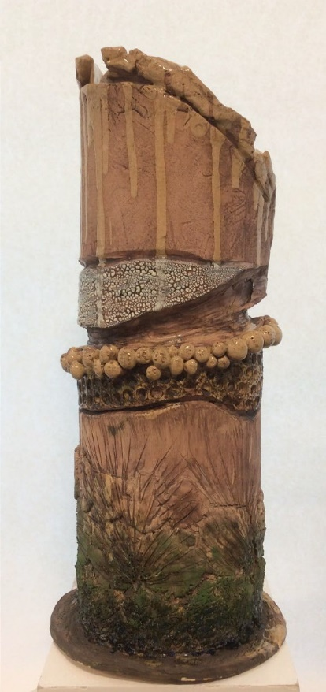
GCSE Art & Design

ART & DESIGN
Why choose GCSE Art & Design?
Are you creative? Are you hard working? Are you artistic? Are you able to work and think independently? Do you have an
attention to detail? If so, you have the right attributes succeed in GCSE Art & Design. Do you enjoy and have ability in art? Can you draw and write about your
ideas effectively? A good standard of work in Art & Design in KS3 is essential for potential success at GCSE level. If this is you, and you want to succeed in a dynamic, rigorous and
creative environment, choose Art & Design!

This subject will suit you if:
- You have enjoyed and performed well in art and design in KS3.
- You enjoy drawing, being creative and exploring different ideas.
- You can confidently use the media you have been taught in KS3.
- You are hardworking, can work independently and communicate your ideas in both visual and written form effectively.

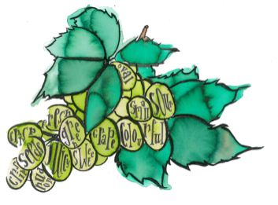
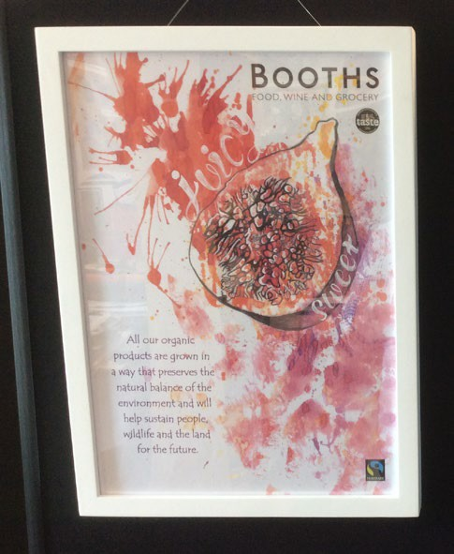
Where does the course lead?
16+: art & graphic design 18+: art, graphic design, illustration, architecture, advertising, teaching, design and creative fields. Universities and employers are always looking for creative people who can generate ideas and work effectively on extended projects from the beginning to a successful conclusion.
Creativity is also increasingly being seen as a vital part of your c.v.

What will the course involve?
Art & illustration - you will explore a range of art & design techniques to visualize ideas, such as painting, printmaking, typography, drawing, mark making, ceramics, sculpture and photography. You will be expected to:
Write detailed annotation – extended writing to show understanding.
of artists, explanations of your own ideas and why you have made your different artistic choices. Develop an idea from initial brief to finished artwork – you will be expected to show independence and be able to make choices which make your work unique and original.
  - You will develop an understanding and the skills to create high level art, design and illustration work aiming towards professional industry standards.
  - Your GCSE Art & Design qualification will encompass and evidence your ability in a range of disciplines and media. Throughout the course of study, you will be helped to consider and refine your skills and determine which area of art & design is most suitable for you.
YEAR 10: SEPT - EASTER: DEVELOPING SKILLS IN MIXED MEDIA & PROJECT 1: ILLUSTRATION. YEAR 10-11: EASTER - DECEMBER: MAJOR PROJECT 2: FINE ART INCLUDING CERAMICS & 3-D. YEAR 11: JANUARY - APRIL: EXTERNALLY SET FINAL EXAM PROJECT.

What additional work is involved?
You will be expected to work independently and extensively at home and after school on research, drawing, writing and photographic tasks; vital to gaining a high final grade.

How will I be assessed?
60% - 2 coursework projects 40% - final exam project Mr. Huntington



GCSE Art and Design
PHOTOGRAPHY

Why choose GCSE Photography?  Are you creative and love taking photos? Are you hard working and independent? Do you have lots of exciting ideas?  Have you always wanted to learn how to use a DSLR camera, understand lighting and photo editing?  Have you seen really cool photos and wondered if you could learn a similar  technique? If so this course could be for you! |  | 
Photography is a highly creative and experimental course where you will use a mixed media approach. |  | This subject will suit you if:  - You have enjoyed and performed well in art and design in KS3;  - You enjoy using computers, being creative and exploring different
 | ideas;  - You are keen to push your ideas forward and are willing to experiment with new techniques;  - You are hardworking, can work independently and communicate your ideas in both visual and written form effectively.


Where does the course lead?
16+: photography, graphic design, art
18+: photography, photo media, film, art, graphic design, advertising, teaching, marketing and other design and creative fields.
Universities and employers are always looking for creative people who can generate ideas and work effectively on extended projects from the beginning to a successful conclusion. Creativity is also increasingly being seen as a vital part of your c.v.
What will the course involve?

Photography and editing - You will be introduced to a wide range of photographic and artistic techniques including light painting, collage, Photoshop, macro photography, bleaching and scratching photos and using different lighting styles.

Detailed annotation – extended writing to show understanding of artists and photographers, explanations of your own ideas and why you have made your different creative choices.

Developing an idea from initial brief to finished piece – you will be expected to show independence and be able to make choices which make your work unique and original.

YEAR 10: SEPT - EASTER: DEVELOPING SKILLS IN PHOTOGRAPHY AND EDITING
YEAR 10-11: EASTER - DECEMBER: MAJOR PROJECTS (COURSEWORK)
YEAR 11: JANUARY - APRIL: EXTERNALLY SET FINAL EXAM

What additional work is involved?
You will be expected to work independently and extensively at home on research, planning, writing and photographic tasks which will be vital to gaining a high final grade.

How will I be assessed?
60% - 2 coursework projects 40% - final exam project





OCR Cambridge Nationals in Creative iMedia
What will the course involve?

The qualification follows the Cambridge Nationals Certificate for Creative iMedia. It consists of 4 units: one is assessed externally through a written examination taken in January Y11 (worth 25% of the overall qualification) this examination is based upon the pre-production skills of digital media and 3 units are internally assessed (totalling 75% of the overall qualification). Here, you will apply technical knowledge and demonstrate mastery of practical and technical skills through realistic tasks and activities.

Creative iMedia

Why choose the Cambridge Nationals?

Creative iMedia will equip you with a range of creative media skills and provide you with opportunities to develop, desirable and transferable skills such as research, planning, reviewing, working with others and communicating creative concepts effectively.

Ultimately you will be creating fit-for-purpose creative media products.
Where does the course lead?
This qualification is for you if you want to start a career in digital media. Achieving this qualification will give you an advantage when applying for a job in the creative industries. The types of jobs include:

- Junior content producer/creative content assistant
- Web Developer
- Graphic Designer

This qualification also gives you a sound basis to progress further within the creative industries to a level 2 apprenticeship, for example in content production or creative digital media, or to a level 3 qualifications.

This subject will suit you if:
- You want to gain further experience with Information Technology
- If you want to learn more about the concepts of digital media
- You are interested in how computers work when creating digital media
- You enjoy producing digital materials (through a project)
- You enjoy writing content for digital media
- You enjoy creating and producing graphical images digitally
- You enjoy creating websites & apps




How will I be assessed?
Unit  Number | Unit Title | Type | How  Assessed?
 | Units
R081 | Pre – Production Skills (Written exam 25%) | Mandatory | External
R082 | Creating Digital Graphics (25%) | Mandatory | Internal
R086 | Creating a digital Animation (25%) | Mandatory | Internal
R087 | Creating a Multi-Media Product (25% | Mandatory | Internal


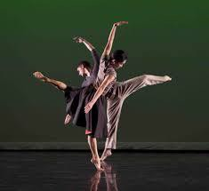

This subject will suit you if:

- You currently dance and wish to progress your skills.
- You enjoy being physically active.
- You have the skills and confidence to perform in front of a live viewing audience.
- You are willing to choreograph and perform a solo performance.
- You can work well and co-operate in a group.
- You are willing to learn new skills and relish a challenge.
BTEC Dance
DANCE

Why choose Dance at Fulwood Academy?
Do you like performing in various styles of dance? Is there a specific style that you like the look of, but have never had the opportunity to learn? Would you like to pursue a career in the dance profession as a performer, choreographer or even a teacher?

If you have answered yes to any of these questions then BTEC Dance may be the course for you. You will be provided with the opportunity to learn and
develop skills in dance styles such as street, jazz, contemporary and lyrical dance genres, as well as being involved in choreographing your own dance routines and working with outside professional dance artists.

Where does the course lead?  BTEC Dance could lead you into various career  paths: performer, choreographer or teacher. It also provides a solid  foundation for progression  onto a wide range of BTEC and A Level courses. |  | What will the course involve?  The specification builds upon skills developed at Key Stage 3 and it is therefore desirable that candidates will have participated in all dance lessons (or attended dance extra-curricular or attend a dance workshop club) and displayed both a professional and enthusiastic attitude towards the subject of dance.  BTEC Tech Award in Dance is a challenging and exciting two year course, designed for those pupils who wish to pursue a career in the Performing Arts Industry and more specifically the area of Dance and who wish to push their physical dance skills and knowledge as far as they possibly can.  There will be a range of various units on offer for pupils to study, covering different aspects of Dance in the Performing Arts industry. Some units focus purely on performance and technique, whilst others focus on planning and developing creative skills.
How will I be assessed?
The BTEC Tech award in Dance is split into 3 components:
- Exploring the Performing Arts
- Developing Skills and Techniques in the Performing Arts
- Responding to a Brief

Throughout the course pupils will be assessed mostly on practical dance skills; however there are units and assignments which require detailed written analysis and evaluation of certain performances as well as theoretical planning and logging of various dance routines. You will be provided with an assignment that will cover each unit of the course and all practical work will be recorded on video for analysis and assessment purposes. Component 1 and 2 are internally assessed via a series of assignments and component 3 is externally assessed that involves being given a task 12 weeks prior to an external examiner visiting the school where you must demonstrate that you can identify and use effectively an appropriate selection of skills, techniques, concepts, theories and knowledge from across the whole qualification in an integrated way.

AQA DRAMA GCSE
DRAMA





.
Component 2- Devising Drama (practical) (40%)
Process of creating devised drama.
Performance of devised drama, log of research and process and analysis of evaluation of own work.

How is it assessed? Total of 80 marks.
Devising log – 60 marks.
Devised performance- 20 marks.
This component is marked by teachers and moderated by AQA.

Component 3- Texts in Practice (20 %)
Performance of two contrasting extracts from one play. Must contrast from play in Component 1.

How is it assessed? 40 marks
Extract one performance – 20 marks.
Extract two performance- 20 marks.
This component is marked by AQA
Component 1- Understanding drama (40%)
Knowledge and understanding of drama and theatre.
Study of one set play from a choice of nine.
Analysis and evaluation of the work of live theatre makers.

How is it assessed? Total of 80 marks.
1 hour and 45 minutes written exam.
Section A: multiple choice (4 marks)
Section B: four questions on a given extract from the set play chosen (44 marks)
Section C: One questions on the work of theatre makers in a single live theatre production (32 marks)

Where does the course lead?
This course is an excellent foundation for those who desire a career within any creative industry, communication field/service or theatre, TV and film. It also sets students in good stead if they wish to progress to A Level or BTEC theatre studies.
This subject will suit you if:

- You have skills in being creative, working with other, performing, being a leader and a team player.
- You can perform in front of others with confidence.
- Work with anyone and share ideas.
- Complete written work in class and independently meet deadlines.
- Interested in the theatre and arts, various genres, and practitioners.
Why chose Drama at Fulwood Academy?
The Performing Arts department strive and are dedicated to deliver a knowledge enriched and practical subject, preparing you with all the skill required for GCSE DRAMA.
This course is suited for all students who love performing, creating and being themselves in a creative space.

WJEC Level 1/2 Vocational Award

HOSPITALITY AND CATERING

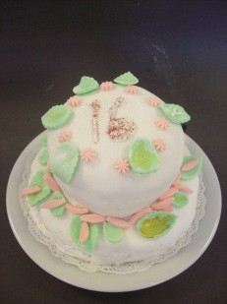

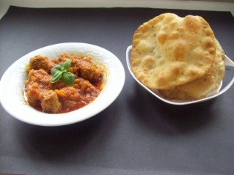









What will the course involve?

What will I study?
This qualification is made up of 2 units.
Unit 1: The hospitality and catering industry.
You will:
Learn about the hospitality and catering industry, the type of hospitality and catering provide and about working in the industry.
Learn about health and safety, food safety in hospitality and catering, and food-related Illnesses.
Unit 2: Hospitality and Catering in action
Learn about the importance of nutrition and how cooking methods can impact on nutritional value. Learn about issues related to nutrition, planning meus as well as factors which affect menu planning. In this qualification, you will learn the skills and techniques needed to prepare, cook and present dishes to a high standard. As well as learning how to review your work effect. Learning transferable skills of problem-solving, organisation and time management, planning and communication.

Where does the course lead?
Ever wondered what it takes to work in a top hotel or restaurant? Do the flavours in the kitchen inspire you? Maybe you are interested in developing the skills you need to work front of house? There are many local colleges that provide advanced qualifications. If so, it’s time to uncover your potential in hospitality and catering. You could also progress into careers that include a chef, dietetics, health and social care, food technologist, nursing, food production and manufacture, nutritionist, hospitality, food product development and childcare.
How will I be assessed?
You will be assessed through a written examination and an assignment.

Starting with Unit 2: You will complete an assignment where you will plan and prepare a menu in response to a brief. This will be worth 60% of your qualification. Like all qualifications, this course requires hard work and commitment. As well as practical work, each week there is a considerable amount of written work.

Unit 1 will be assessed through a digital examination which is worth 40% of your qualification.

Skills you will develop.
You will develop a range of skill which are attractive to employers, colleges and universities including:
Communication, Confidence, Learning independently, Organisation, Problem solving, Research,
Self- discipline, Stamina, Taking responsibility, Time management

Careers with hospitality and catering

The hospitality industry offers a wide range of exciting opportunities which includes:

Chef de partie, Commis chef, Concierge, Executive chef, Front of house manager, Head waiter, Housekeeper, Maitre d'hôte, Pastry chef, Receptionist, Sous chef.

Once you have learned and developed your skills, the world is your oyster with qualifications behind you.




Where could this subject take you?

This is a very useful option for anyone considering entering the care profession, whether childcare, nursing or social work. This option is also useful for anyone wanting to work with people, as you develop an understanding of physical and emotional development of children and adults. It is a very useful option for understanding how to be healthy and promoting healthy lifestyle choices.
Why choose Health and Social Care at Fulwood Academy?

This course provides students with an engaging introduction to the health and social care sector. You will gain a focused understanding of health and social care through the units which have been selected, and the content is delivered in a way which is meaningful and work related.
Students will gain knowledge of how to develop and maintain a healthy lifestyle and the work of care professionals.

During the course you will study a range of topics including:

- Human lifespan and development;
- Health and social care services and values;
- Health and well-being;
What will the course involve?

You will be expected to complete coursework independently at home and in lessons. This will involve some research into different aspects of health and social care. There are also opportunities to extend your knowledge and understanding through visits and work experience.
BTEC Tech Award
Health & Social Care





This subject will suit you if:

Skills: You will need to be well organised and to be able to work independently and as part of a group. Extended writing skills are also useful, although these are developed throughout the course and there are lots of opportunities to practice them. It is also important to be inquisitive and ask questions about things which others take for granted.

Abilities: Meeting deadlines and taking on teacher feedback is essential for success in this subject. To do well in coursework tasks, the ability to listen to and take on board a variety of opinions is important for success.

Interests: An interest in people and their wellbeing is essential. You must be interested in the health and care of children and adults from all areas of society and be interested in understanding how to promote the wellbeing of people within society.
How will I be assessed?

To achieve the Award (equivalent of 1 GCSE) you will complete 4 pieces of coursework and will sit one controlled assignment.


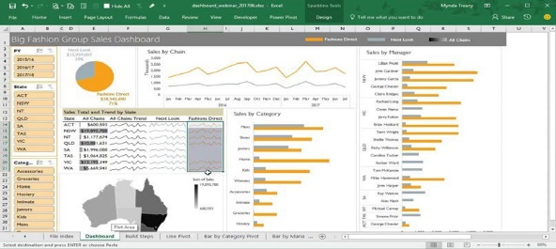


The Pearson BTEC Level 1/Level 2 Tech Award in Digital Information Technology

Digital Information Technology

Why choose the BTEC IT?
If you like the idea of creative iMedia qualification, but want more from your qualification in terms of information technology, then this course is for you! You will have an opportunity to study some aspects of media design (user interface design). Although, you will also be able to take advantage of learning skills in project planning techniques, studying the knowledge, understanding and skills related to data management and digital working practices.
Where does the course lead?
This qualification is for you if you want to start a career in IT, application design or be able to use IT to manage a business.

This qualification gives you a sound basis to progress further to:
A Levels as preparation for entry to higher education in a range of subjects.

Study of a vocational qualification at Level 3, such as a BTEC National in IT, which prepares learners to enter employment or apprenticeships, or to move on to higher education by studying a degree in the digital sector.

This subject will suit you if:
  - You want to gain further experience with Information Technology
  - You want to learn more about the concepts of user interface design principles
  - You are interested in how computers work when creating user interface designs and database dashboards
  - You have or are willing to learn skills using Microsoft Excel and App design software
  - You enjoy writing about what you have learned and review your practices
  - You enjoy learning about how technology is used in different organisations
  - You enjoy learning about digital systems and the wider implications associated
What will the course involve?

This qualification has three components of study outlined below. The first two components are internally assessed assignments that are subject to external standards verification and the third component is externally assessed and builds directly on Components 1 and 2, which will enable your learning to be brought together and related to a real-life situation. You can expect to take the examination for this component as early as February, with resits in May.


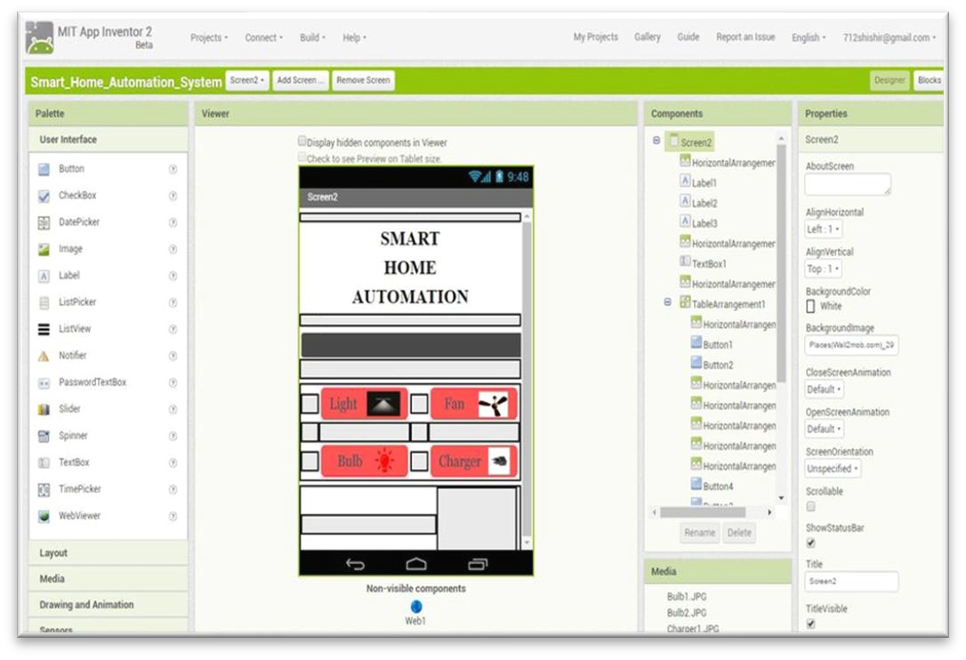

How will I be assessed?
Unit  Number | Unit Title | Type | How  Assessed?
 | Units
Com 1 | Exploring User Interface Design Principles and Project Planning Techniques (30%) | Mandatory | Internal
Com 2 | Collecting, Presenting and Interpreting Data (30%) | Mandatory | Internal
Com 3 | Effective Digital Working Practices (Written Exam 40%) | Mandatory | External

GCSE
RELIGIOUS STUDIES


This subject will suit you if:

- You have an interest in how different people believe they should live their lives and the decisions they make based on their faith;
- You have an inquisitive mind and are able to discuss on paper as well as orally;
- You have a desire to see the world in a deeper and more philosophical way;
- You want to learn about different ethical issues such as whether the death penalty should be used to punish criminals, or whether it is ever acceptable to start a war.

What will the course involve?
Why should I choose Religious Studies at Fulwood Academy? Religious Studies gives you a chance to
consider the realities of the world around you and develop your own opinion on important issues by exploring the variety of views held around the world.

R.S. is an academic, rigorous and valuable qualification for entry to post 16 education. All universities accept and welcome pupils with R.S. onto a variety of courses.

Employers look for an enquiring mind and
R.S. helps us to appreciate and respect different viewpoints whilst developing an ability to evaluate, analyse and justify different points of view.


In Religious Studies you will learn about beliefs and practices from two different religions and study ethical issues which are relevant to the world around you. Some of the topics you will cover lead on from your KS3 RE lessons and the skills you have learned at this level will help you with the work required for the Religious Studies GCSE.
Where does the course lead?
Religious Studies can lead you into various career paths due to the skills you acquire in this subject. Many students go on to study journalism, law, public services, humanitarian work, and medicine (due to the ethics content of the course). It also provides a sound basis for progression onto a wide range of A Level courses. It is a highly valued course by colleges and universities.

How will I be assessed?
You will have to complete two exams at the end of Year 11.

Component 1: The study of religions: beliefs, teachings and practices – 1 hour 45 minutes

In Component 1 you still study 2 Christianity and Islam in depth and learn how to explain the beliefs and practices from each religion. You will be assessed on your ability to explain a person’s actions based on their beliefs and how well you can explain the meaning of religious teachings.

Component 2: Thematic Studies - 1 hour 45 minutes

In Component 2 you will study at least 4 different topics investigating ethical issues and philosophical questions. These include learning about;
- Relationships and families
- Religion and Life
- Religion, peace and conflict

- Religion, crime and punishment
These topics are considered from religious and non-religious points of view and allow you to form justified opinions about controversial issues in the world today.

In your examinations you will need to demonstrate the following written skills; building a sustained persuasive argument, explaining and analysing religious attitudes in great detail and debating conflicting ideas. You will also be assessed on your spelling, punctuation and grammar.
Therefore, to succeed in R.S. you need to have good English skills, enjoy writing and debating.



Why choose Health and Fitness at Fulwood Academy?

This NCFE Health and Fitness course follows on from the Key Stage 3 physical education programme of study by providing students with exciting opportunities to lead a healthy and active lifestyle. You will learn more about the human body and the systems that allow us to exercise and how we can improve our fitness.
The content of Health and Fitness is designed to enable students to enjoy and understand the benefits of living a healthy and active lifestyle; to provide a route to further study in further education awards, such as A Levels and to higher education in P.E.
NCFE VCERT
Health and Fitness (PE)


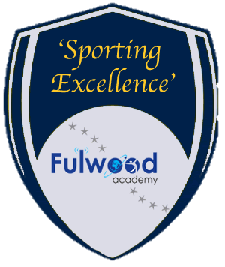
Where could this subject take you?
This course will give you the skills and subject knowledge to prepare you for studying P.E. and sport at higher education. This can lead onto further education at College, University or further training. There are numerous career pathways that can stem from choosing Health and Fitness. These are often specialist areas like sports coaching, sports development and/or sport and exercise sciences. You could become a fitness instructor, P.E. teacher, physiotherapist, nationalist, sports coach or work within the leisure and recreation industry. Sport is growing more and more each year and there are jobs that exist now that didn’t several years ago. If you enjoy sport and being healthy then choosing Health and Fitness will allow you to have many options available to you.
How will I be assessed?

- This image below outlines course information and also shows how you will be assessed if you choose Health and Fitness.
- Essentially this is two units, one exam unit (40%) and one coursework unit (60%).
- Unit 1- 48 hours guided learning. 40% exam.
- Unit 2- 72 hours guided learning. 60% synoptic project.
- Pupils are graded: NYA, L1P, L1M, L1D, L2P, L2M, L2D, L2D*

This subject will suit you if:

- You enjoy keeping fit, healthy and participating in a variety of sports and activities.
- You enjoy being taught interesting new topics and are giving the chance to explore/enhance your learning outside the class room;
- You enjoy being challenged both mentally and physically.
What will the course involve?

There are 8 content areas that you will cover over the two years:
1: Structure and function of body systems
2: Effects of health and fitness activities on the body
3: Health and fitness and the components of fitness
4: Principles of training
5: Testing and developing components of fitness
6: Impact of lifestyle on health and fitness
7: Applying health and fitness analysis and setting goals
8: The structure of a health and fitness training programme and how to prepare safely

The above content areas will be assessed in two ways:
Unit 1: A written exam worth 40%
Unit 2: A synoptic project (coursework) 60%
Core Subject
CORE RELIGIOUS



What does Core RE involve?
In year 10, pupils receive two lessons per fortnight of core RE and then in year 11, pupils will be on a half termly rotation between core RE and Maths and English intervention. Whilst on the core RE rotation, pupils will have twos lessons per fortnight.
In lessons, pupils will have the opportunity to discuss and debate a range of different ethical issues that are relevant in society today. These lessons will allow for pupils to learn a variety of beliefs, but also expand on their own ideas.
Examples of the topics covered in Core RE are;
- Medical ethics
- Crime and punishment
- Extremism
- War and Peace
Why do we study Core RE at Fulwood academy?
Core RE is studied at Fulwood Academy so pupils have rich and diverse understanding of the modern world. Through studying core RE pupils are able to see the impact that religion can still have in society today, whilst also exploring responses to key ethical issues in society today. Core RE provides a space for pupils to explore their own beliefs and responses to these ethical issues.


This Photo by Unknown Author is licensed under CC BY
How can Core RE help my other subjects?

Although Core RE is not a examination based subject, it helps to develop skills that are useful for other subjects that pupils will take examinations in. Since pupils will be discussing and debating views on different ethical issues, this will help them develop skills in explanation, analysis and evaluation which would be helpful in written based subjects such as English, History and Geography.

As there is a lot of opportunity for verbal contribution in Core RE, this can aid pupils that will be taking non exam assessments in Drama and English Language as they are developing their oracy skills.

GCSE Music
MUSIC

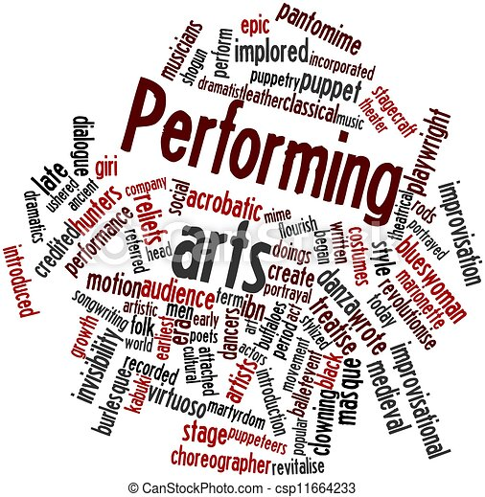
Why should I choose GCSE Music?
It will provide transferable skills
GCSE music involves written, analytical, practical and
social/personal skills such as:
• independent learning: having to be disciplined about
practising on their instrument or voice
• team working: particularly if they’re involved in weekly groups or ensembles, concerts and performances
• performance and presentation skills which are useful for any job/career
• listening: this is highly developed in musicians and it is an important part of the course
• analytical skills
• confidence and self-esteem: which has a knock-on effect in all areas of life and learning
• creativity and self-expression: helping young people to think differently and harness the power of their imagination.


What jobs can I get with a GCSE in Music?

Artist manager, Broadcaster, Music Agent, Music Producer
Music Therapist, Musician, Private Music Teacher, Radio Producer, Secondary Music Teacher, Sound Technician, Sound Designer, Sound Engineer, Special Effects Technician, Theatre Sound Design

How will I be Assessed?
60% of your GCSE will be Non-Exam Assessment.
This will include 2 compositions and 2 performances on your chosen instrument.
40% of your GCSE will be a listening exam at the end of Year 11.

Do I need to play an instrument?
YES! Although with this GCSE, that doesn’t have to mean an instrument in the traditional sense. You could beatbox, sing, rap, DJ, and present a sequenced performance.
If you don’t already learn an instrument, you need to start learning now – with regular lessons from a suitably qualified teacher. Speak to Mrs Holding for more information


What will I study?
There are 5 Areas of Study:
- My Music
- The Concerto through time
- Rhythms of the world
- Film Music
- Conventions of Pop

GCSE
GCSE STATISTICS
This subject will suit you if:

- You push and challenge yourself;
- You are able to work independently and pro-actively;
- You seek to understand the world around you in more depth.
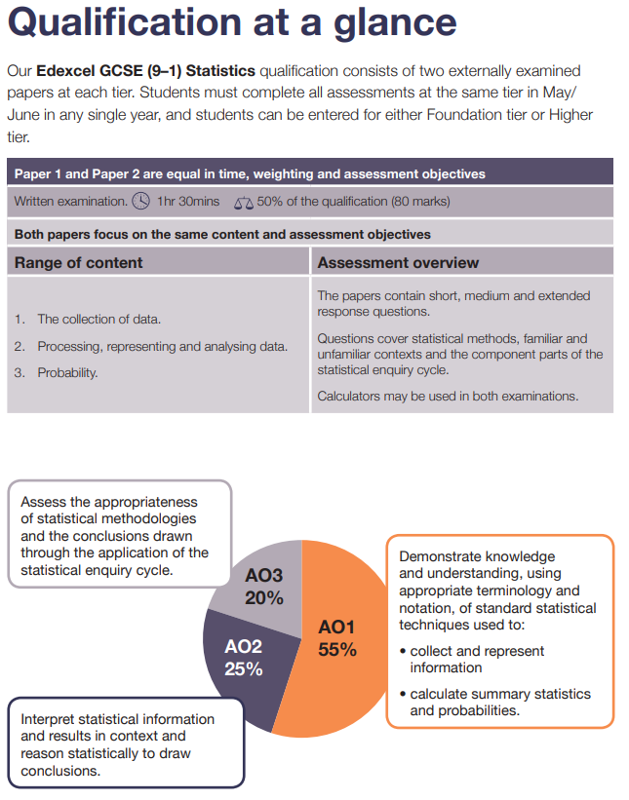

Where does the course lead?

Mathematics is a vital part of everyday life. As well as the obvious uses of numbers there are a variety of careers that on mathematics qualifications e.g. engineering, architecture and medicine at A Level.

GCSE
Travel and Tourism
This subject will suit you if:
- You enjoy learning about the world around you and how people, places and organisations are connected
- You are willing to develop your independence, organisation and problem-solving skills
- You are motivated to challenge yourself and take pride in producing your best work

What will I learn?
You will explore:
- How travel and tourism organisations operate
- What makes destinations attractive to visitors
- How companies meet customer needs
- The factors that affect global travel, including sustainability

Course Content (3 Components)
Component 1: Travel and Tourism Organisations and Destinations
- Different types of travel and tourism
- How organisations work together
- Features that make destinations appealing
- Travel routes and transport
Component 2: Customer Needs in Travel and Tourism
- Market research and travel trends
- Customer needs and preferences
- Selecting products and services
- Planning a holiday for a specific customer
Component 3: Influences on Global Travel and Tourism
- Factors affecting global travel
- Impacts of tourism on destinations
- Sustainable tourism and managing tourism growth

How is it assessed?
- Assessment: 60% coursework (Components 1 & 2) and 40% external
exam (Component 3)


Pearson BTEC Level 1 / Level 2 Tech Award
Travel and Tourism
Why choose Travel & Tourism?
- A fast-paced, global industry with exciting career opportunities
- Learn about the world, destinations and cultures
- A practical, vocational course that links learning to real-life work
- Develop key skills such as planning, communication and problem solving



Where does the course lead?

- Further study in Travel & Tourism, Business or Hospitality
- Careers in airlines, tourism, events, hotels, travel agencies and more

GCSE
Business Studies
This subject will suit you if:
- You are interested in how businesses operate and make decisions
- You enjoy discussing real-life examples from the world of work and current affairs
- You are willing to develop skills in analysis, evaluation and extended writing
- You want to understand how money, people and marketing influence business success
- No prior knowledge of Business Studies is required.


Where can this course lead?
GCSE Business Studies provides a strong foundation for further study, including:
- A Level Business Studies
- A Level Economics
- BTEC or vocational courses in business, finance or management. It also supports:
- Business management and administration
- Marketing and advertising
- Finance and accounting
- Human resources
- Entrepreneurship and self-employment
The skills developed through Business Studies — communication, numeracy, analysis and decision-making — are highly valued by employers and transferable to many future pathways.

What will the course involve? This qualification has three mandatory units:
Unit R067: Enterprise and Marketing Concepts
This is assessed by an exam. In this unit, you will learn about the key factors to consider and activities that need to happen to operate a successful small start-up business.
Topics include:
o Characteristics, risk and reward for enterprise, Market research to target a specific customer, What makes a product financially viable, Creating a marketing mix to support a product, Factors to consider when starting up and running an enterprise.
Unit R068: Design a Business Proposal
This is assessed by a set assignment. In this unit, you will identify a customer profile for a specific product, complete market research to generate product design ideas, and use financial calculations to propose a pricing strategy and determine the viability of their product proposal.
Topics include:
o Market research, How to identify a customer profile, Develop a product proposal for a business brief, Review whether a business proposal is financially viable, Review the likely success of the business proposal.
Unit R069: Market and Pitch a Business Proposal This is assessed by a set assignment. In this unit, you will develop pitching skills to be able to pitch your business proposal to an external audience. Finally, you will review your pitching skills and business proposal using self-assessment and feedback gathered.
Topics include:
o Develop a brand identity to target a specific customer profile, Create a promotional campaign for a brand and product, Plan and pitch a proposal, Review a brand proposal, promotional campaign and professional pitch.

Why choose Business Studies?
Business Studies helps pupils understand how businesses operate in the real world and how decisions are made in response to customers, competition and economic change. Pupils will explore how businesses start, grow and succeed, while developing skills that are valuable across a wide range of subjects and careers.

