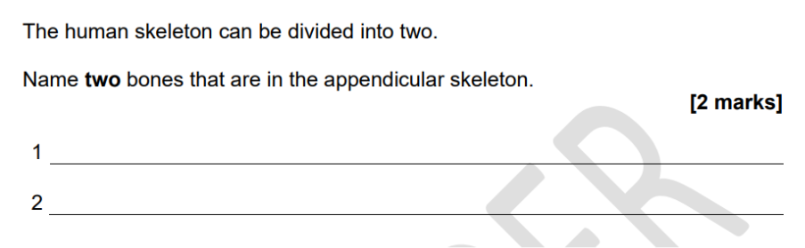
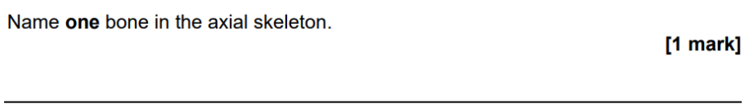
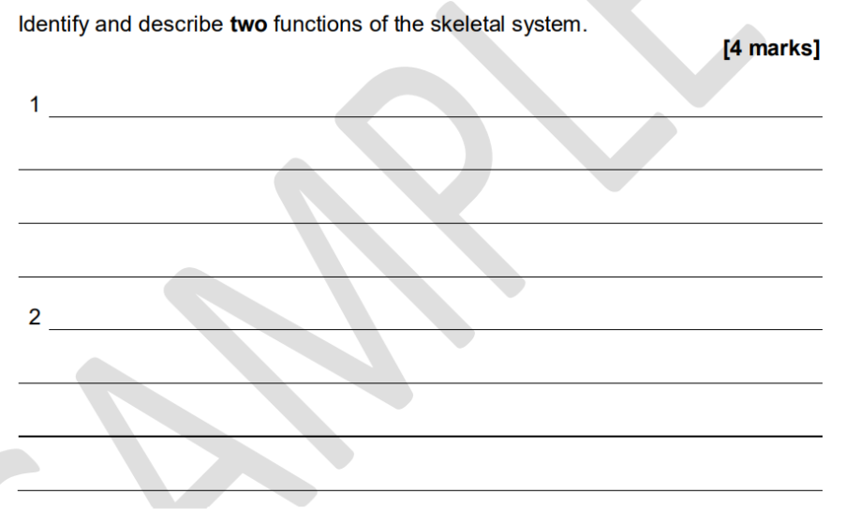

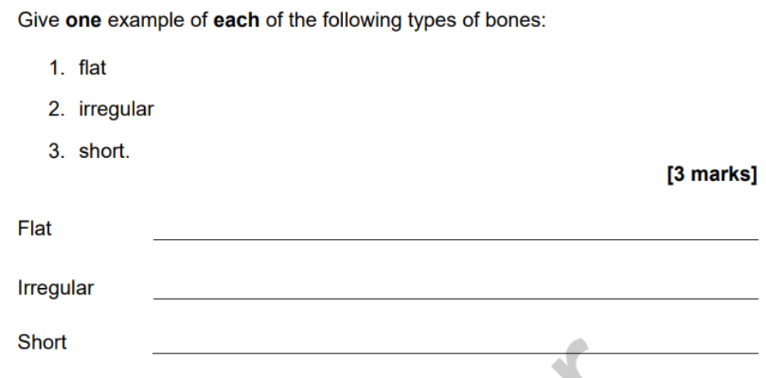
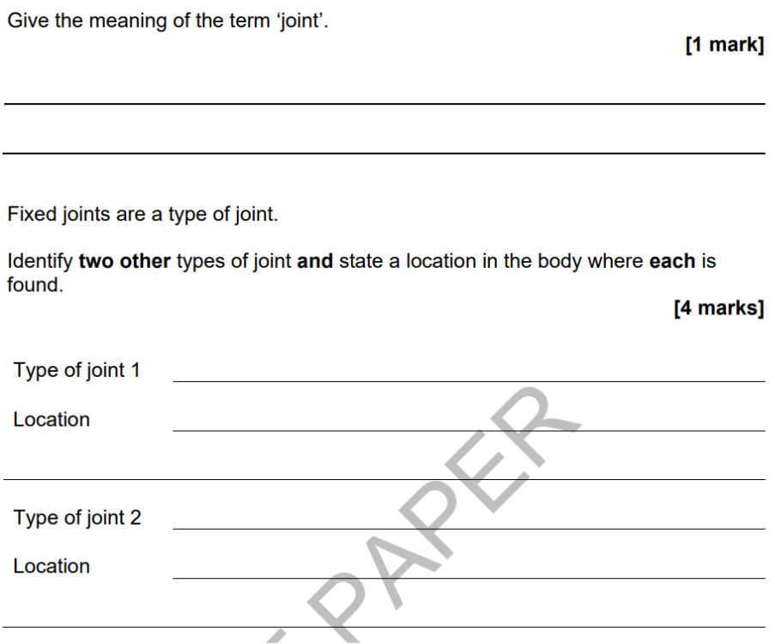

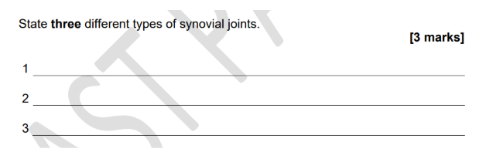

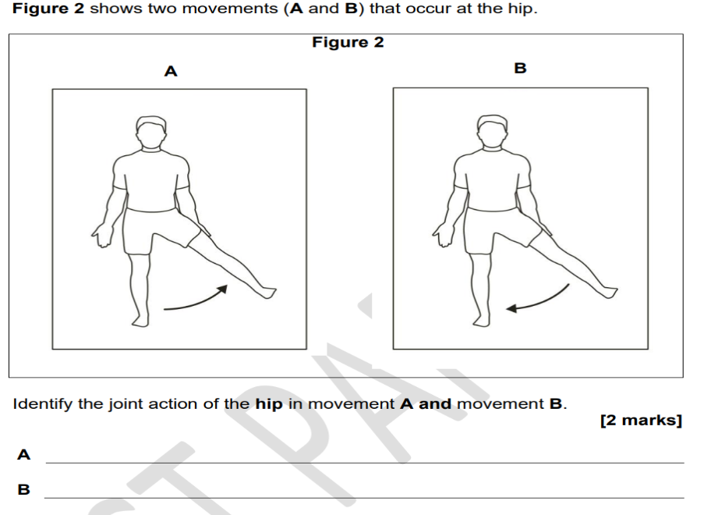

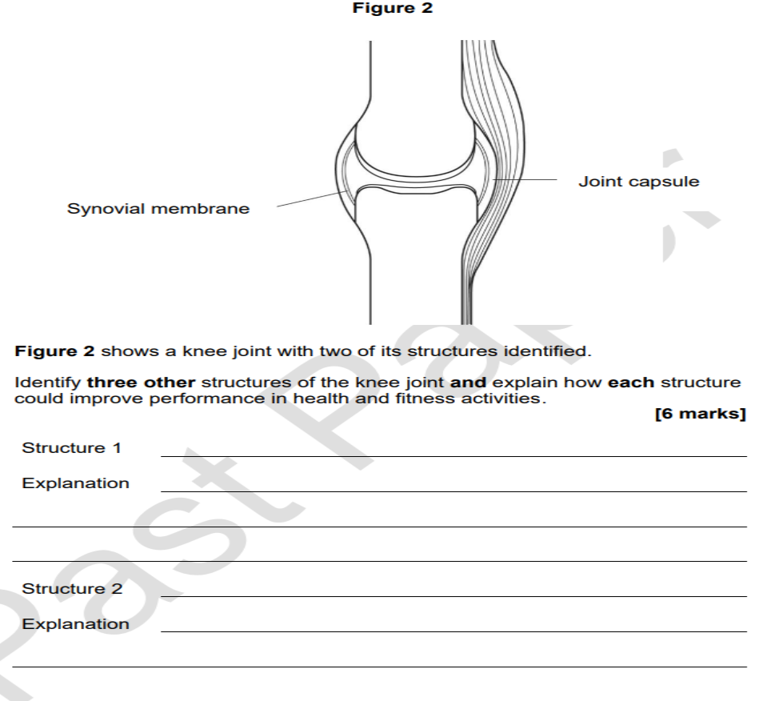
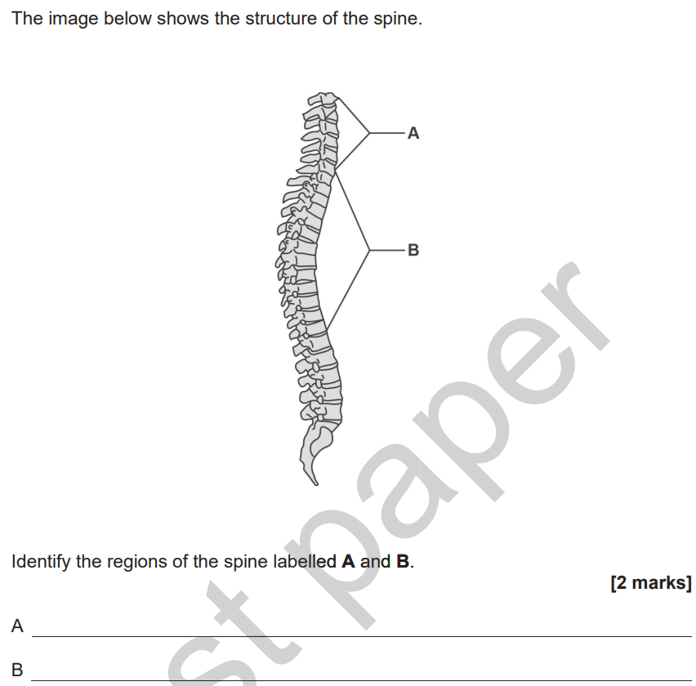

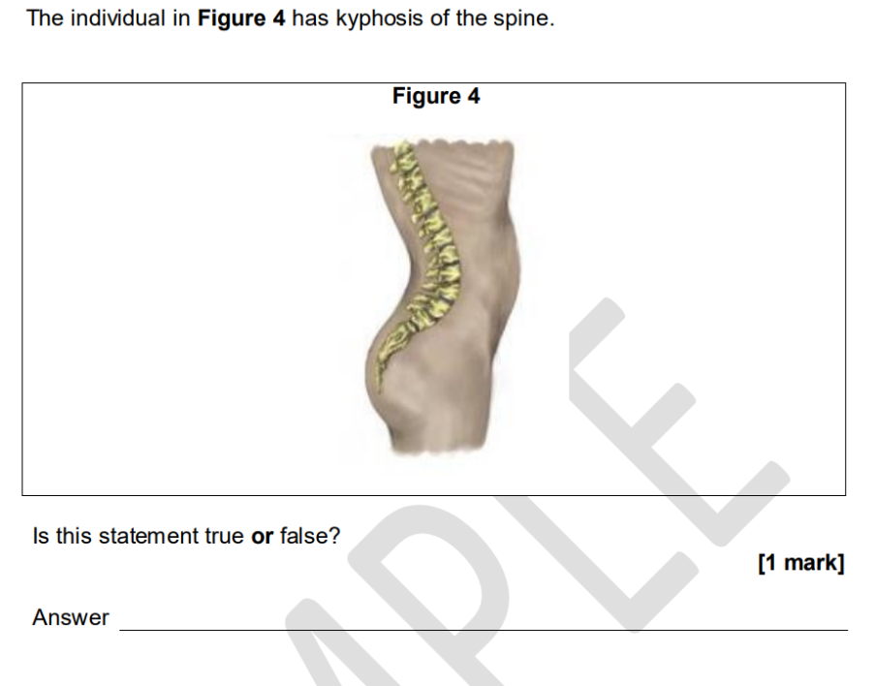

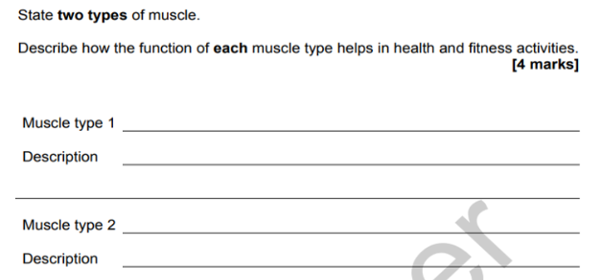

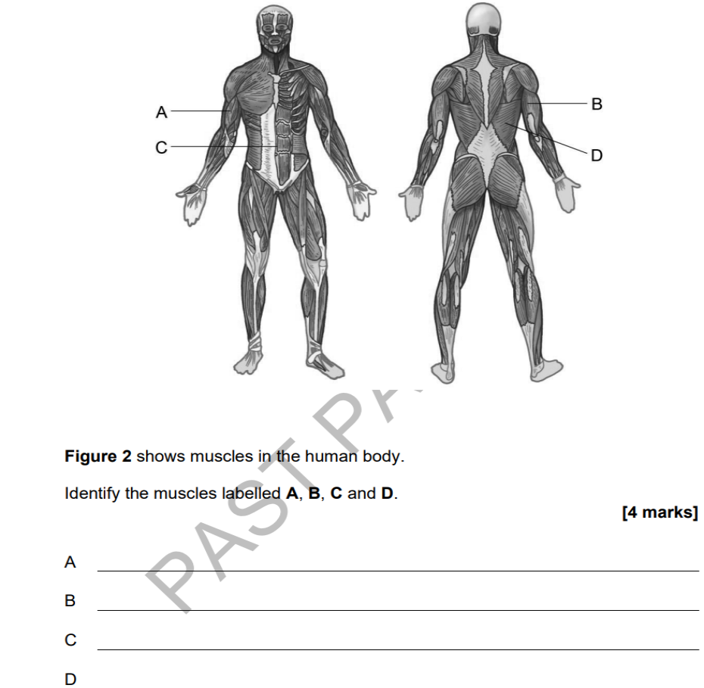

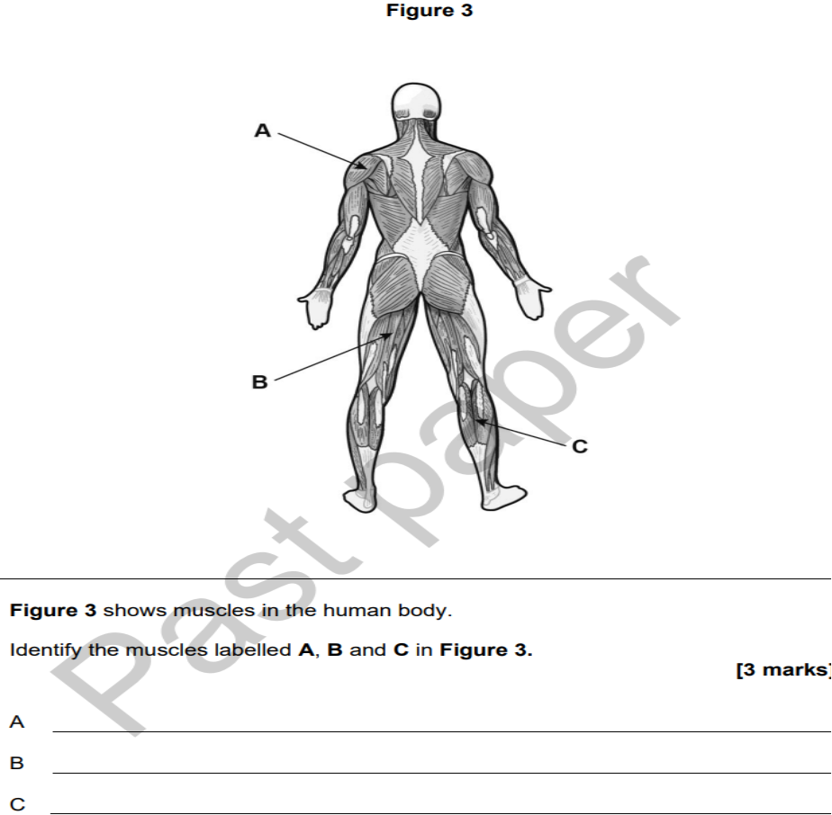

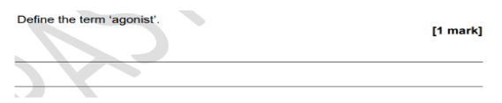

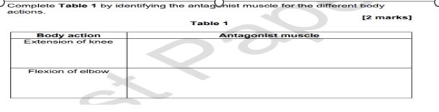

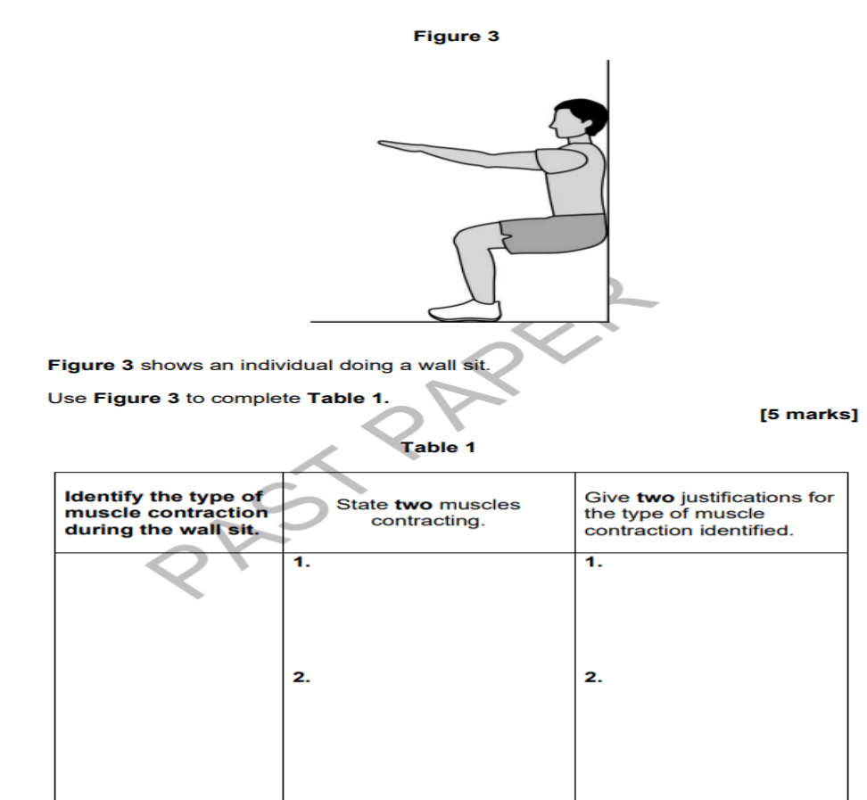

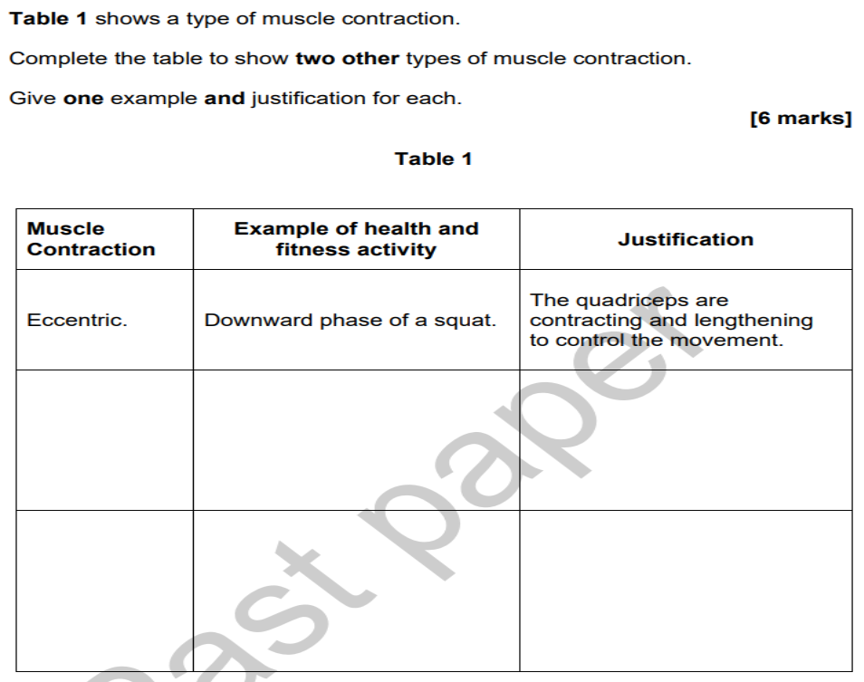
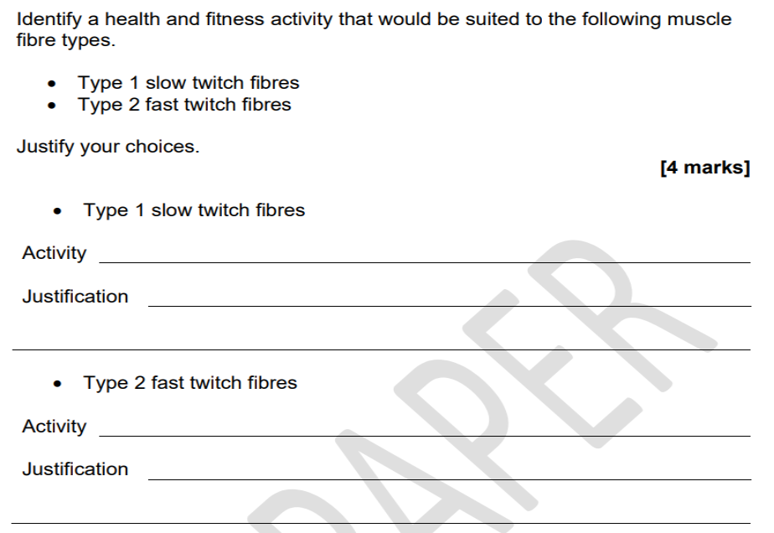

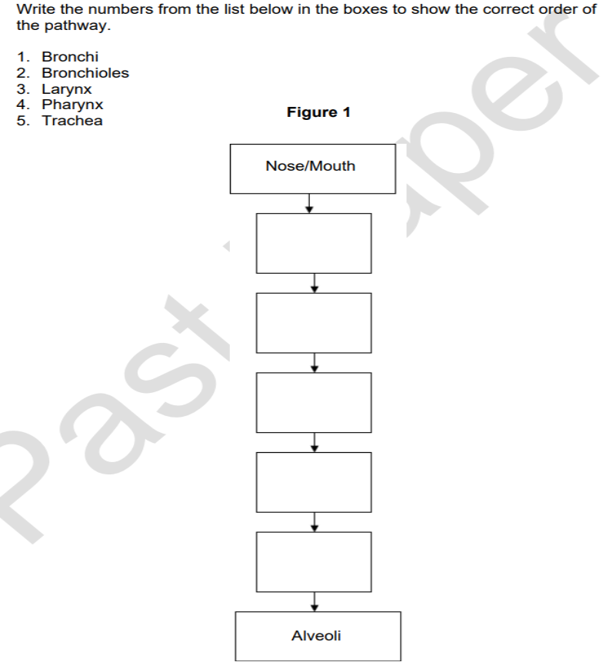
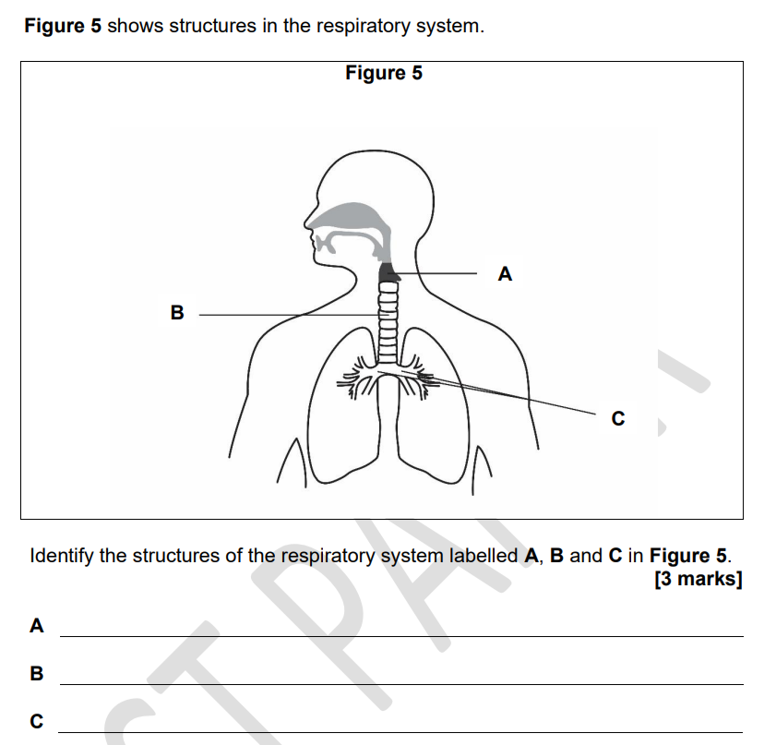

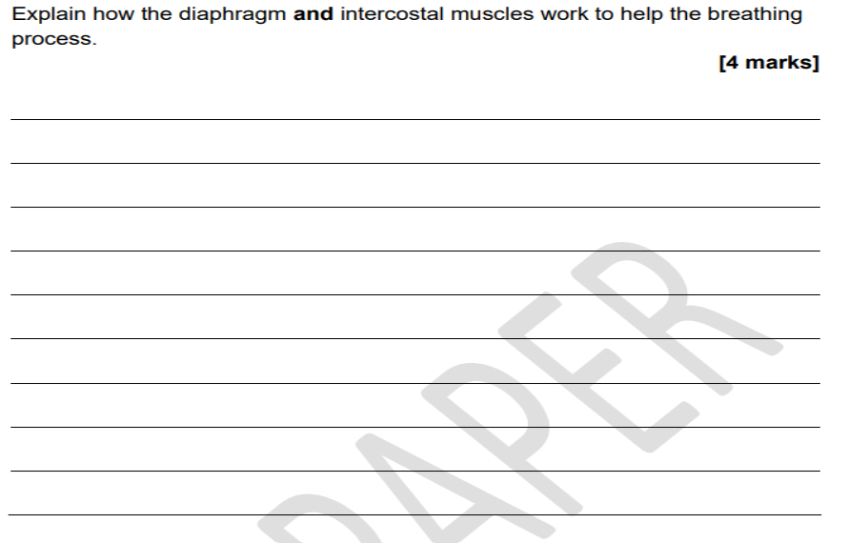
Question on GE and diffusion to go here

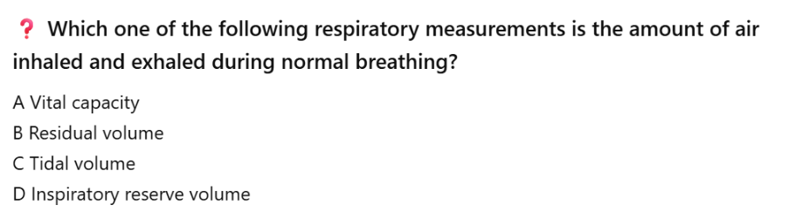
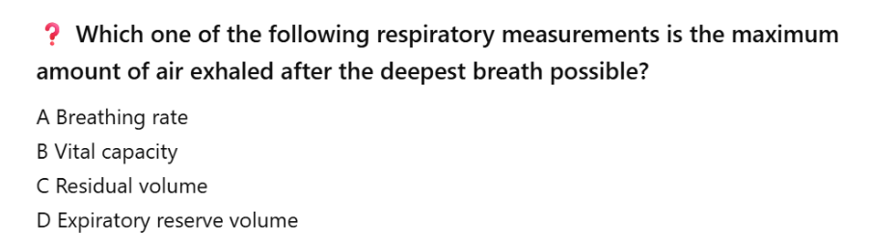
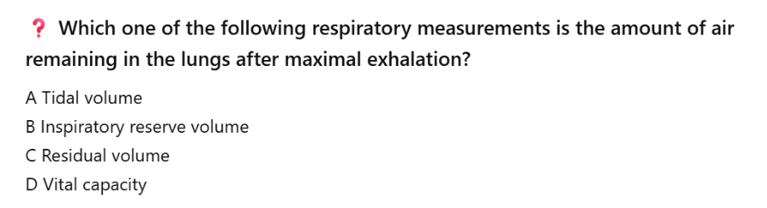
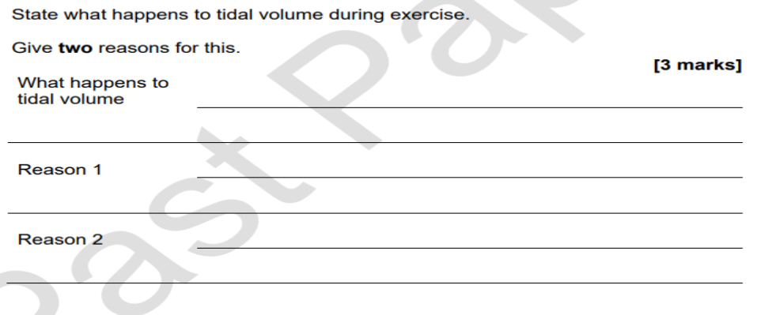

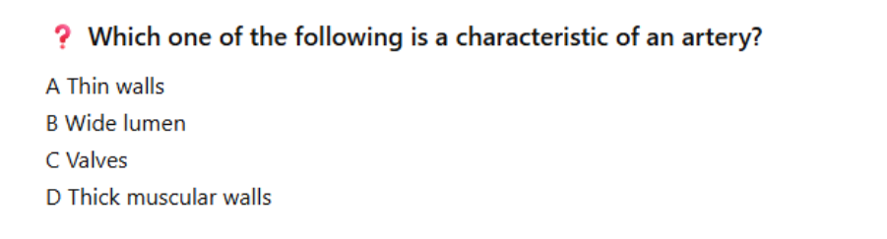
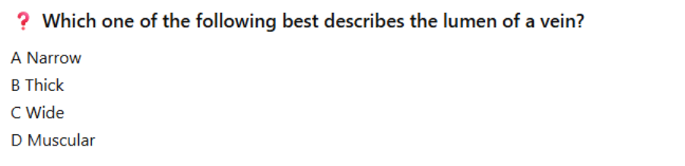
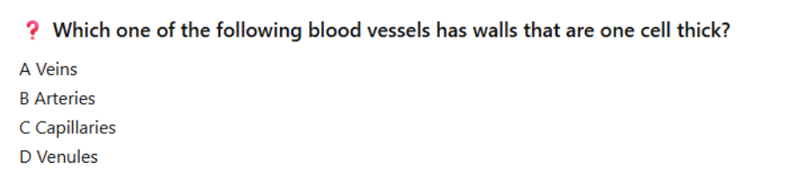
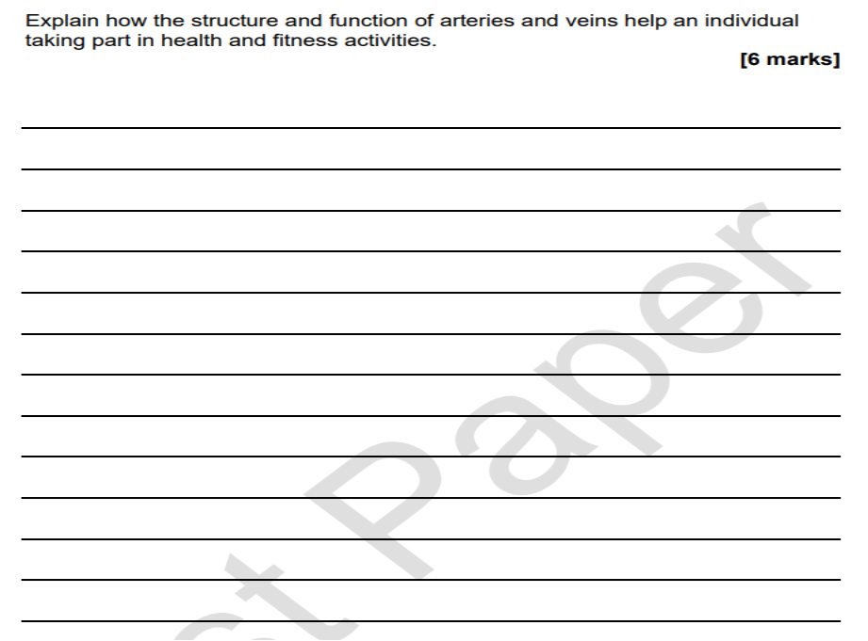
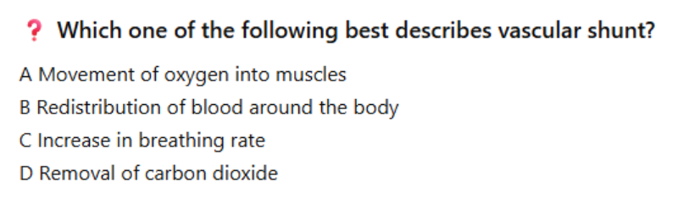
to the working muscles
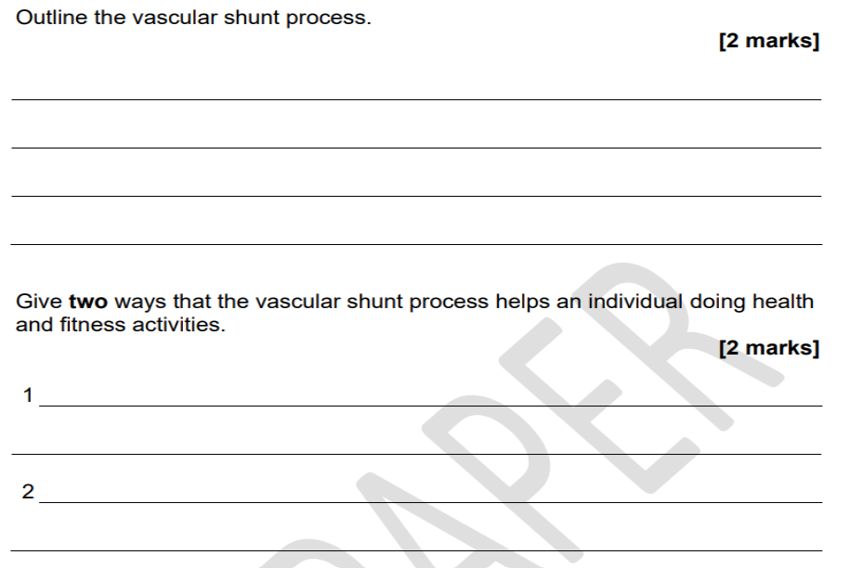
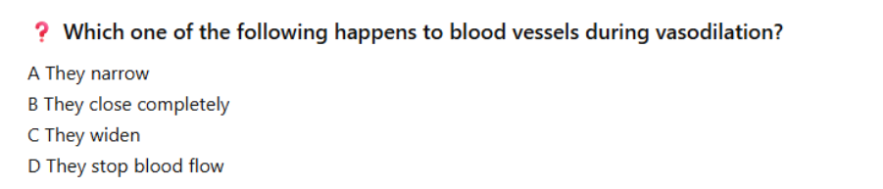
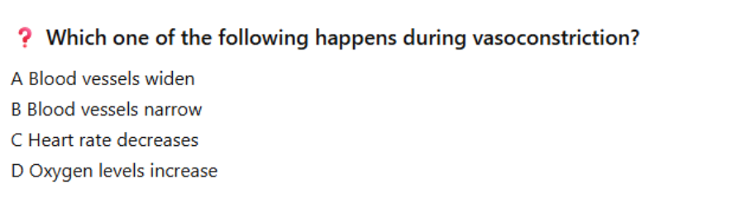
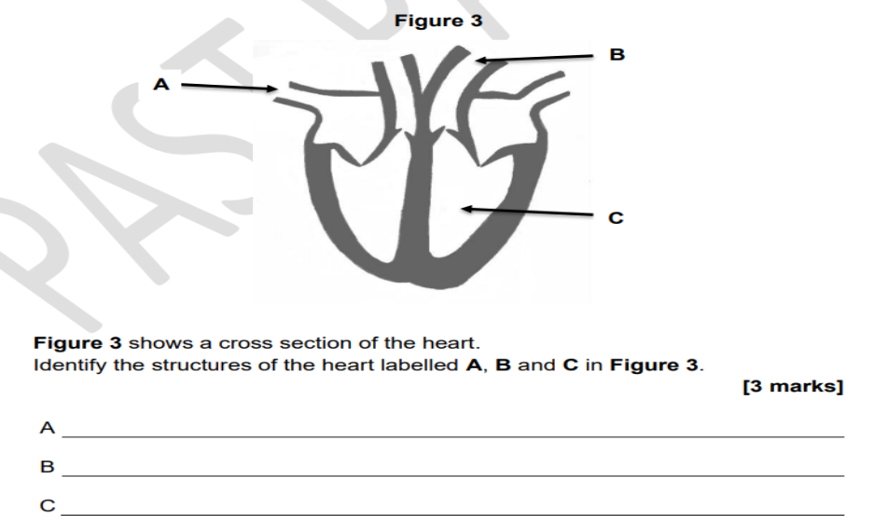

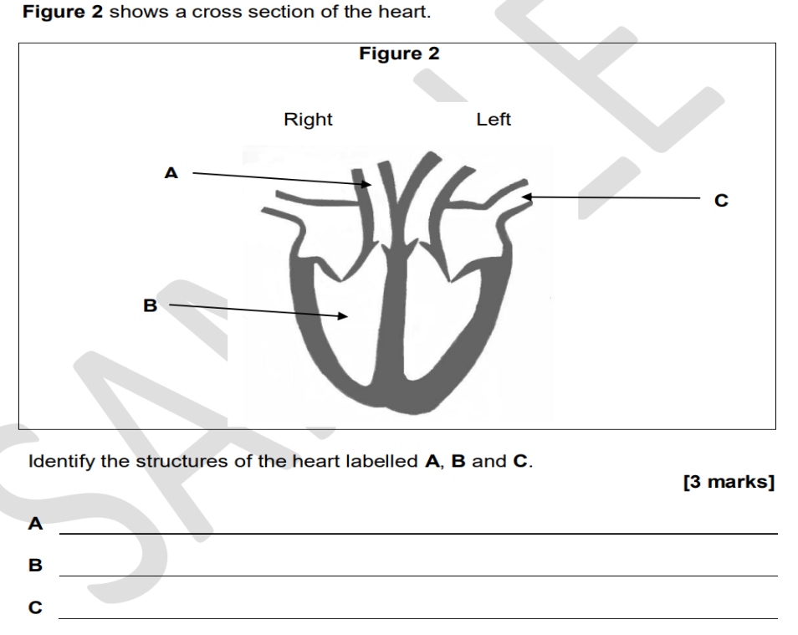

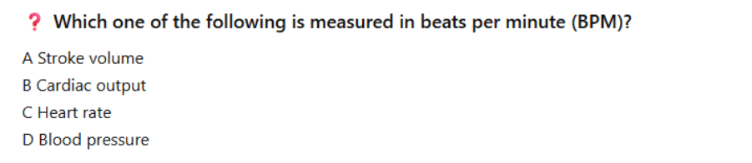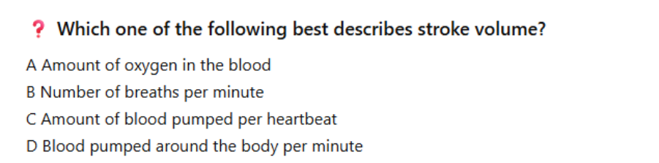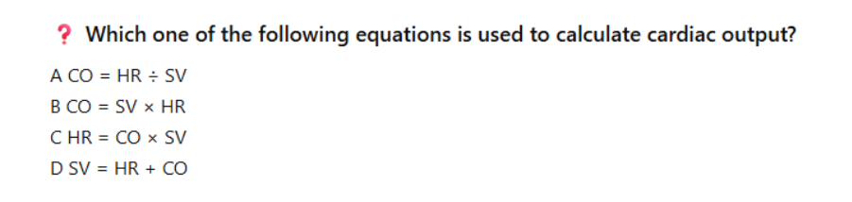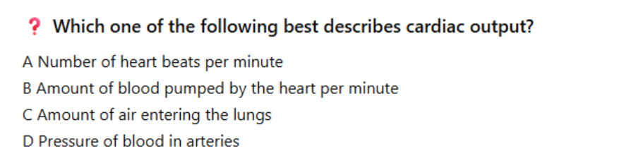
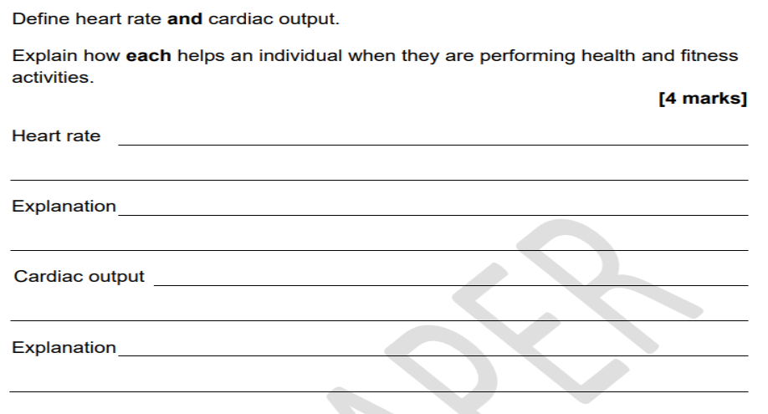
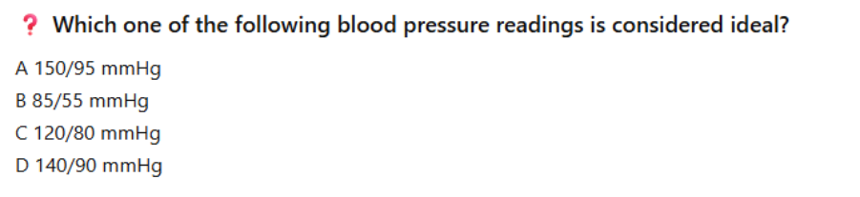

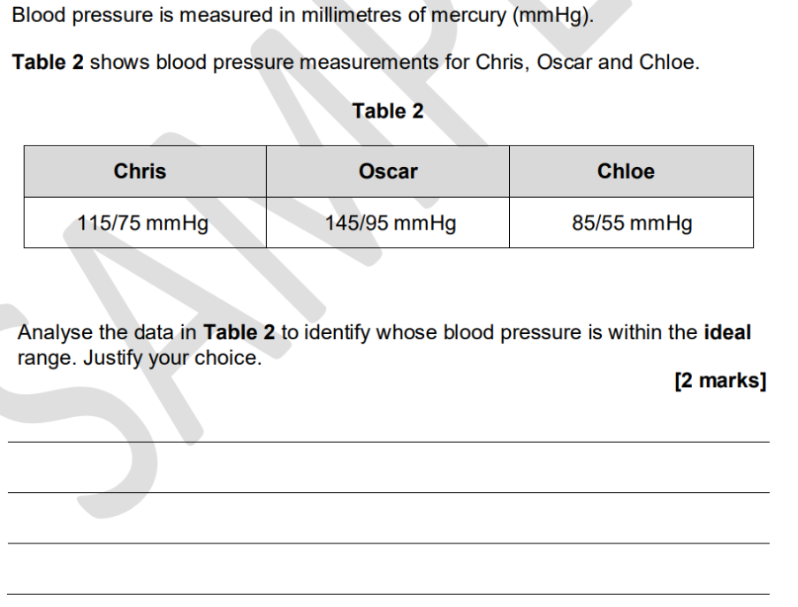

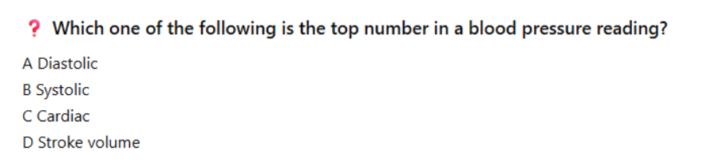

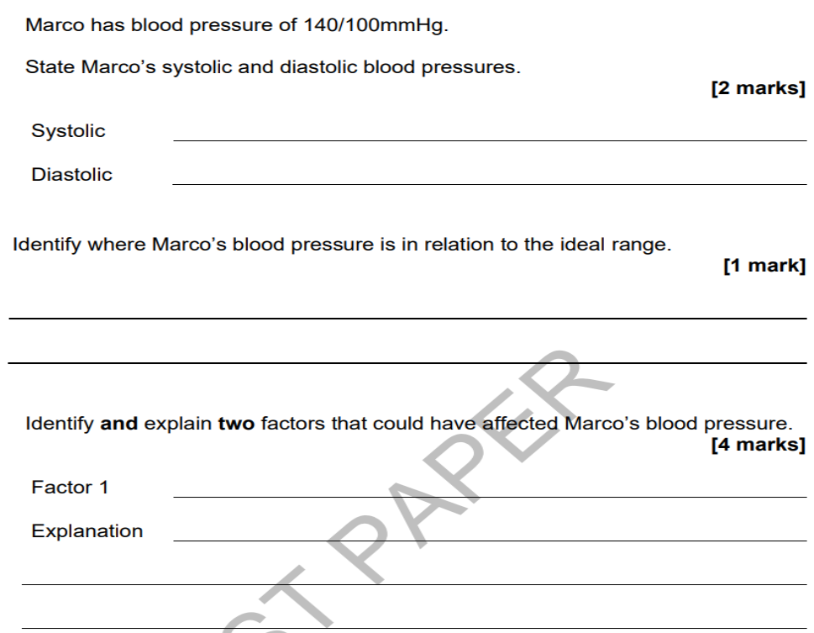
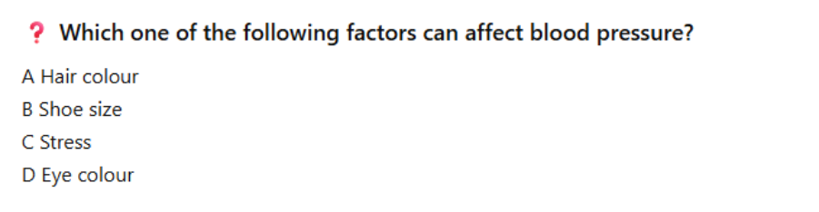
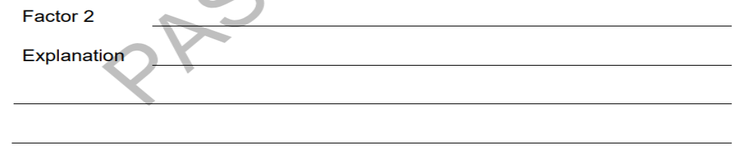

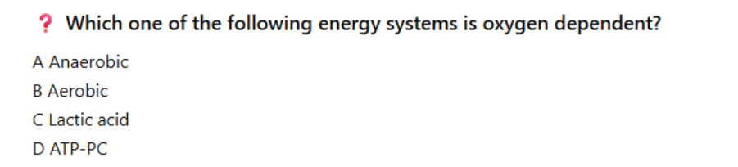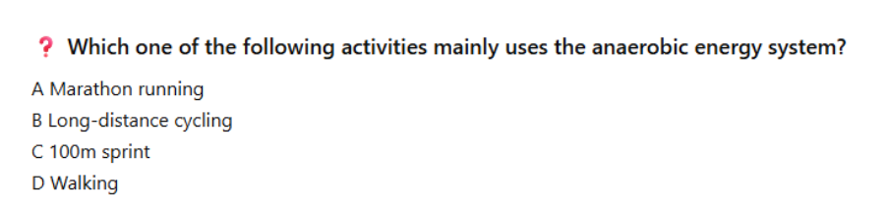
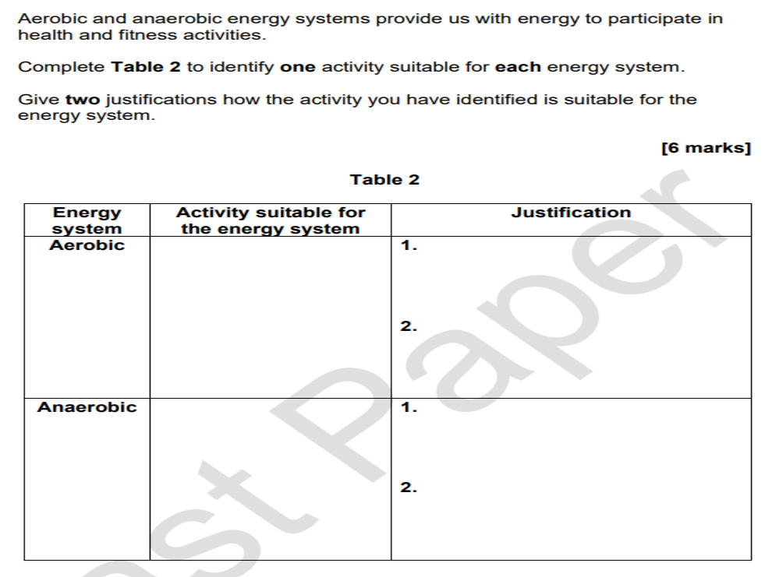

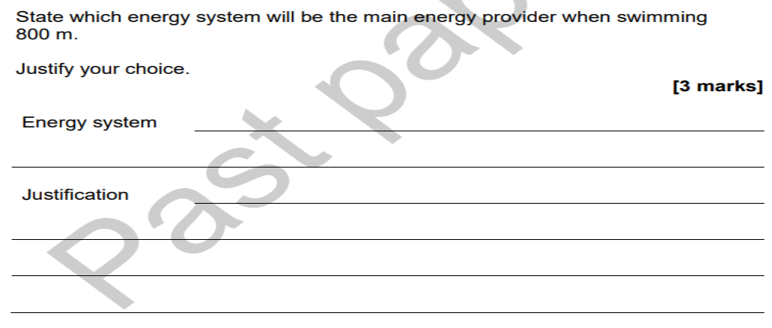

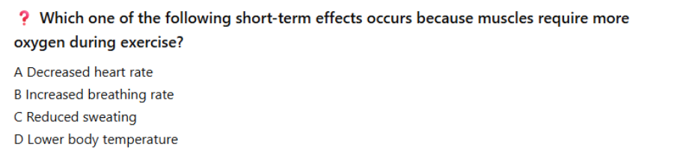
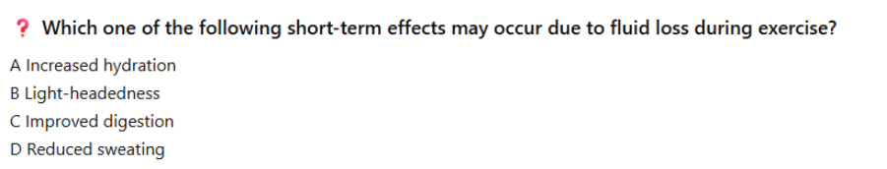

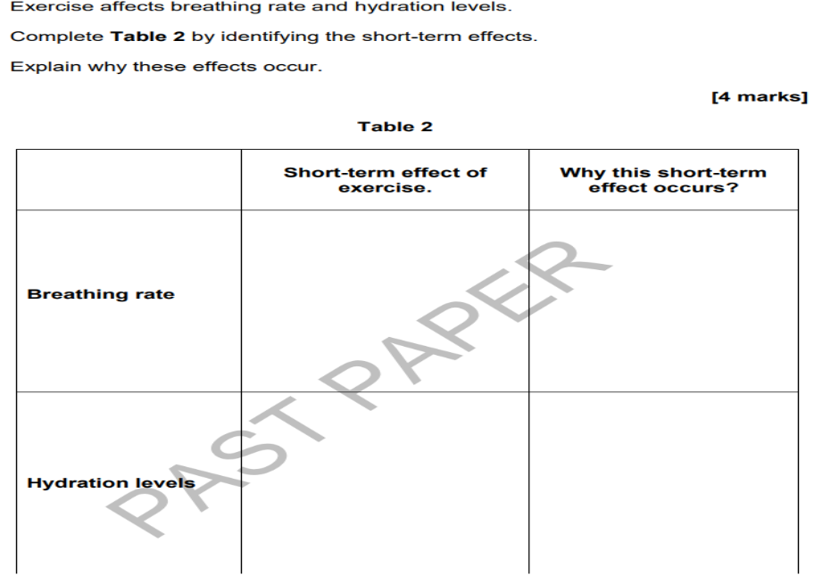

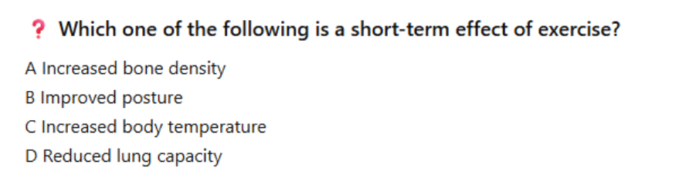
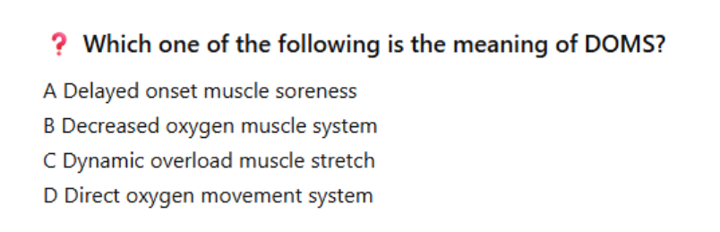

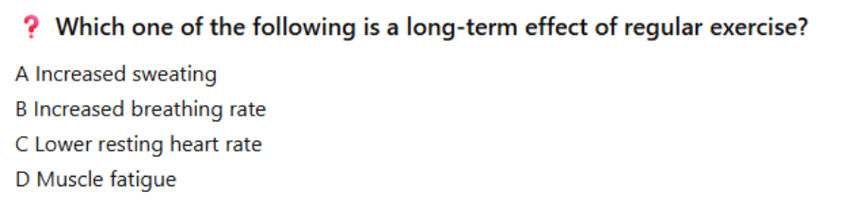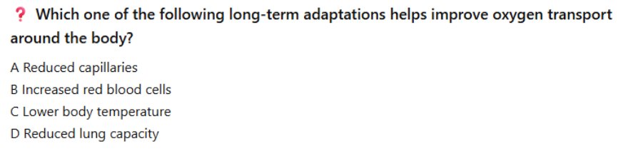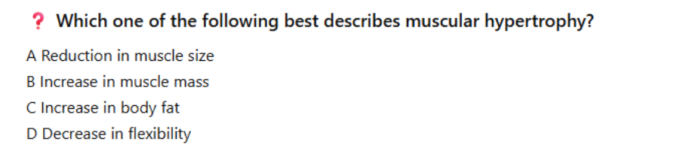
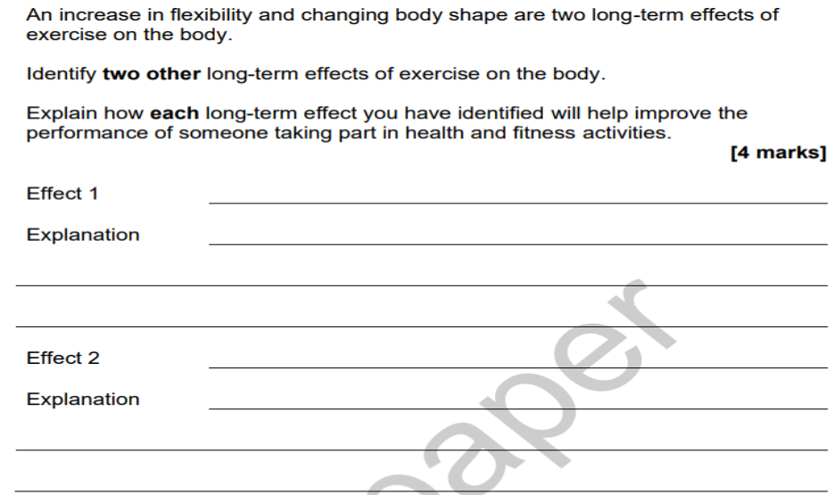
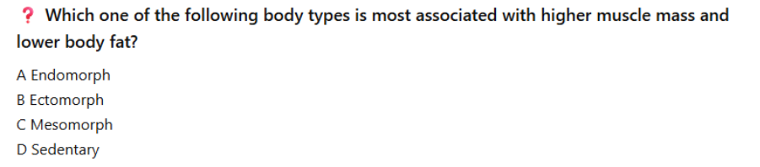

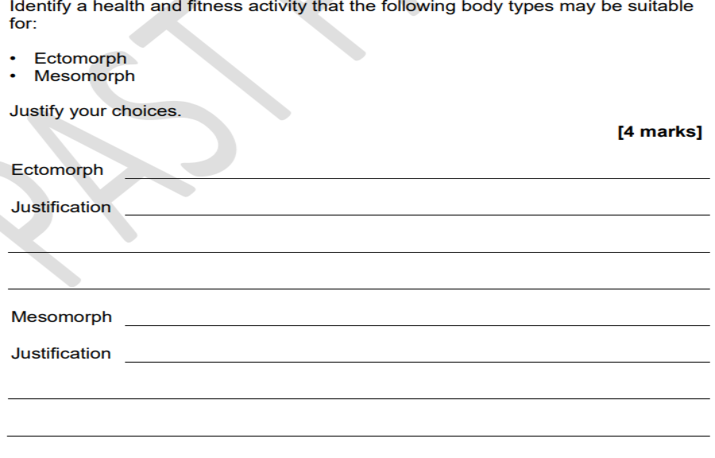

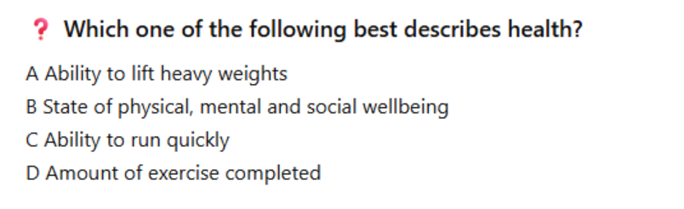
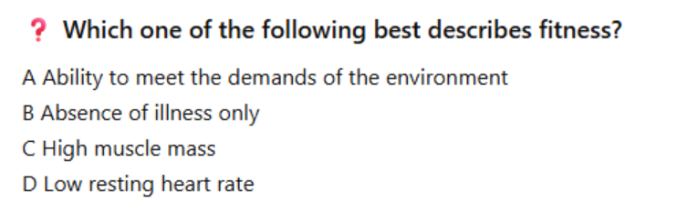

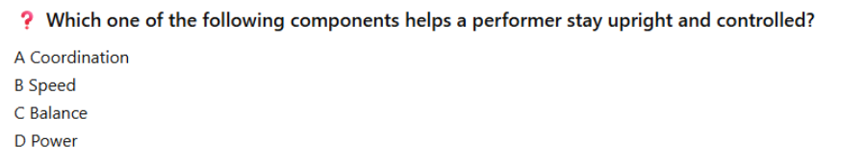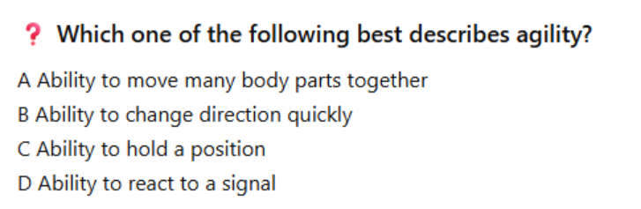
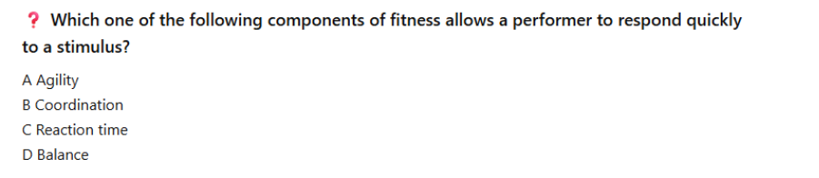
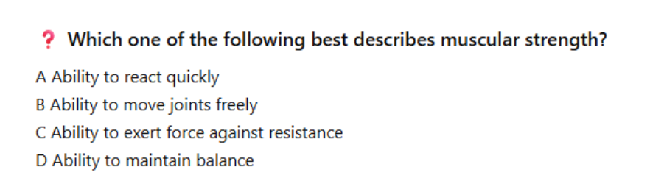
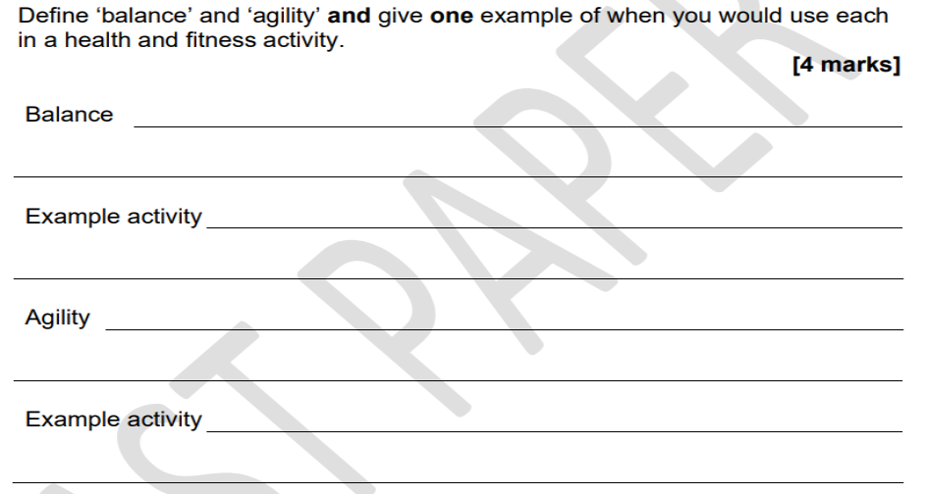

Define body composition
__________________________________________________________________________________________________________________________________________________________________

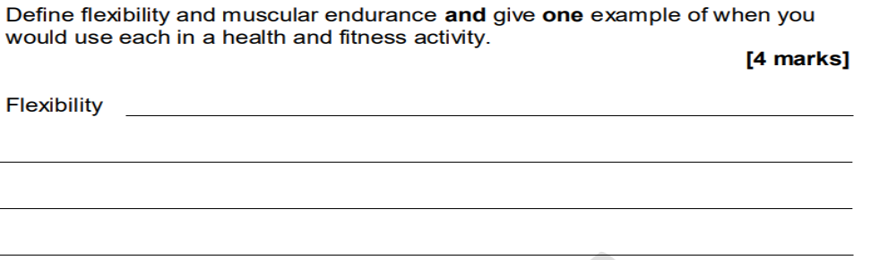

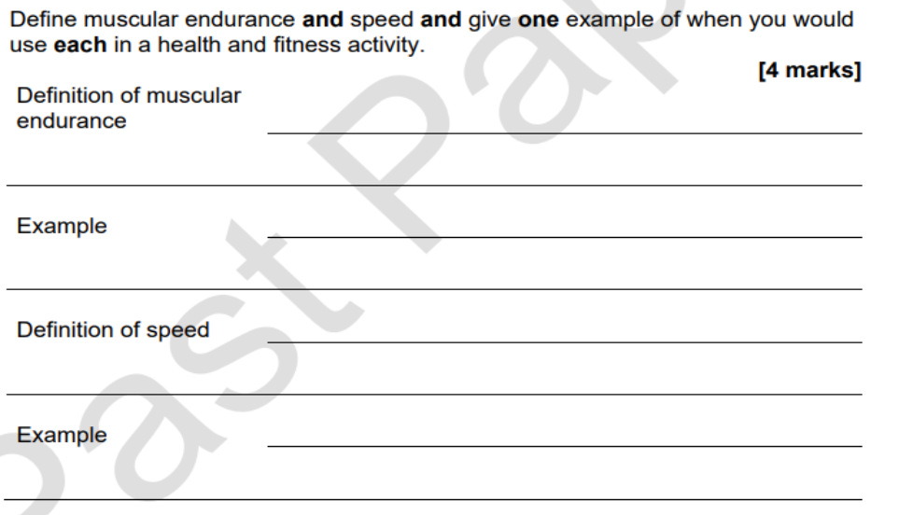

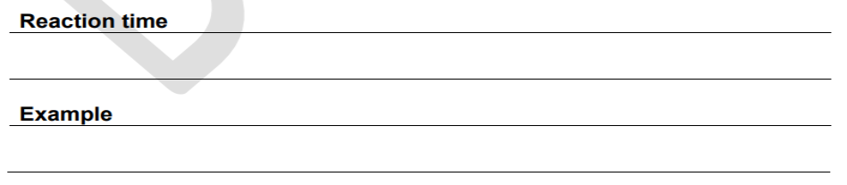
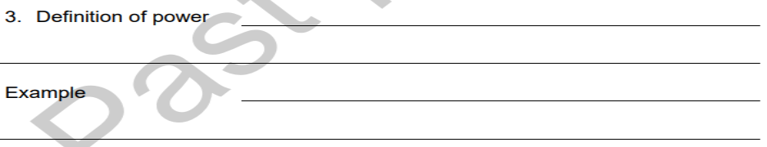

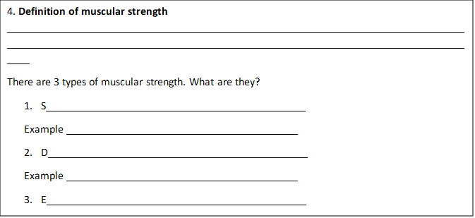

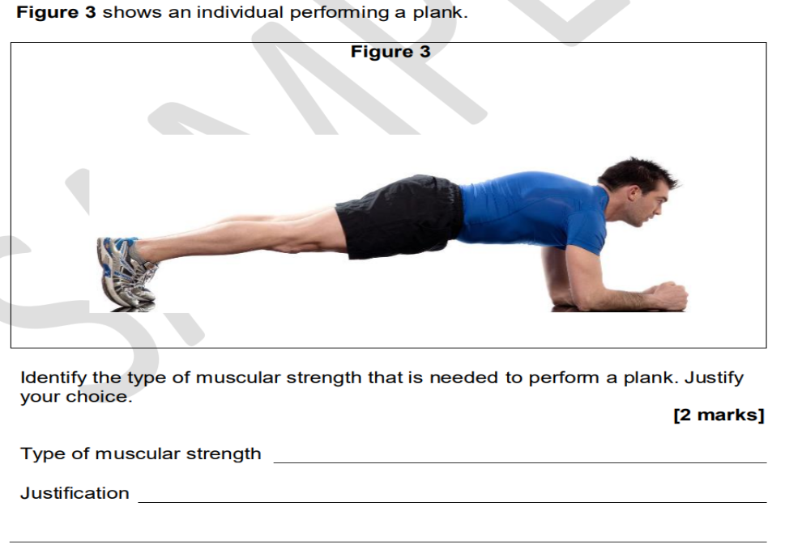

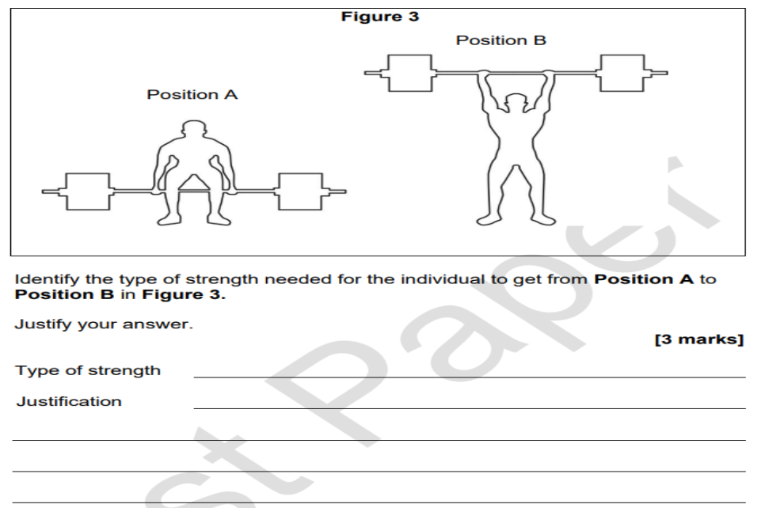
The movement requires both strength and speed to move the weight quickly and powerful from the floor to above the head

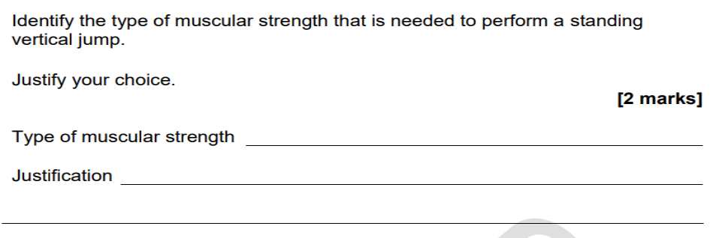
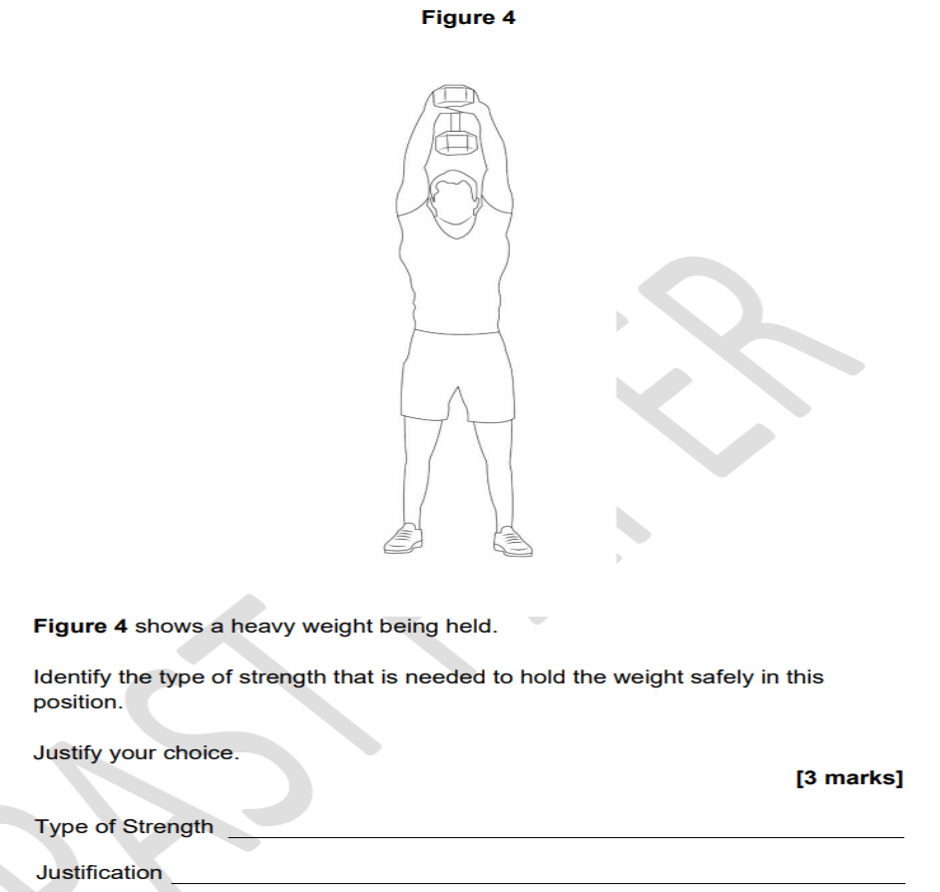

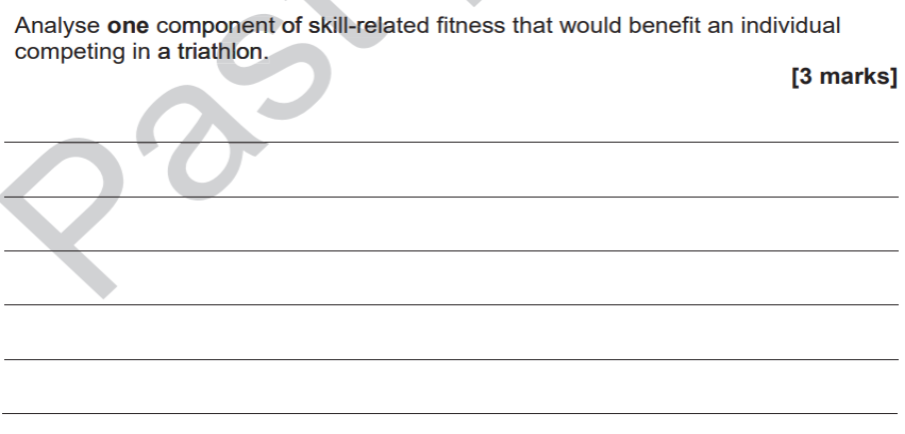
Health related
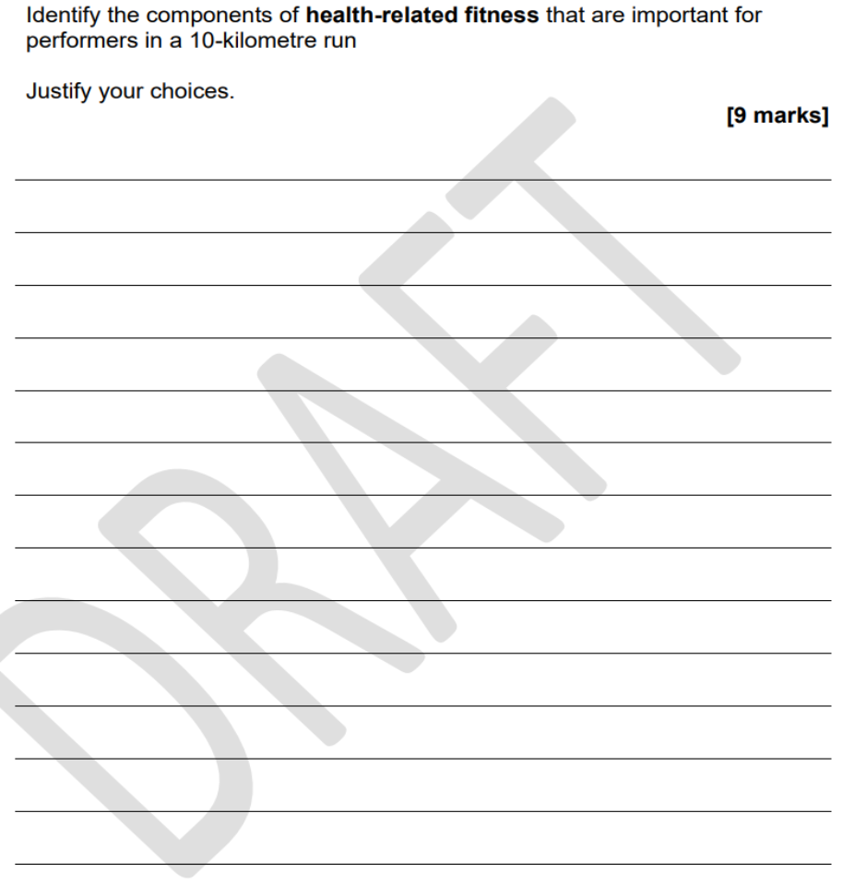
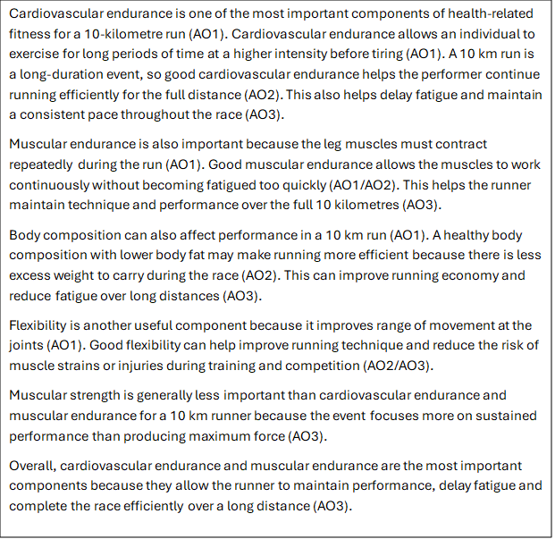

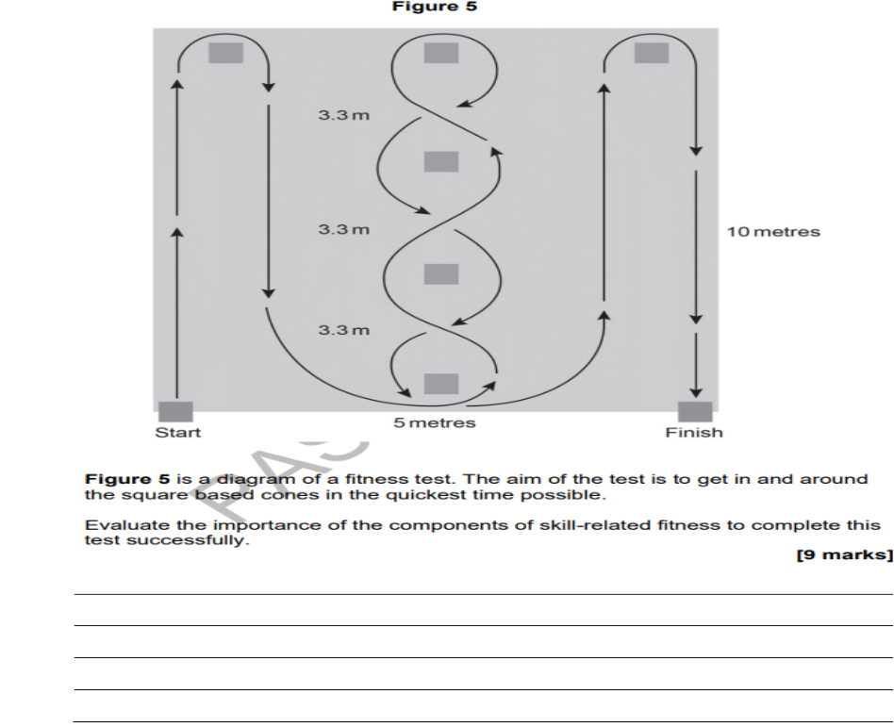
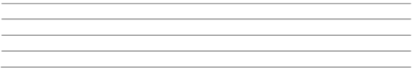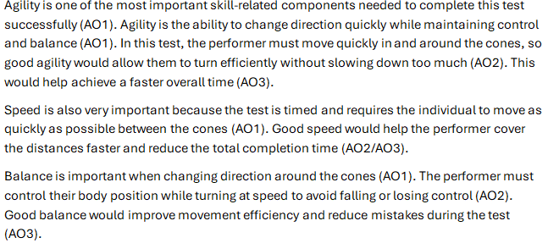

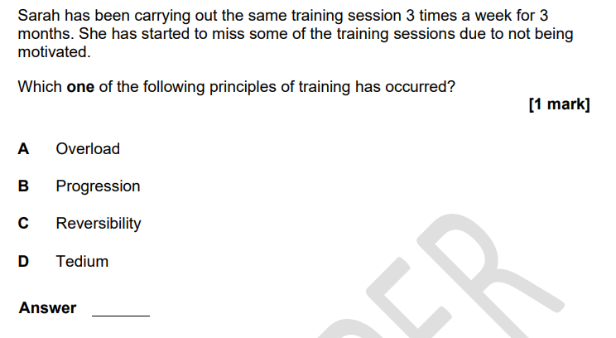
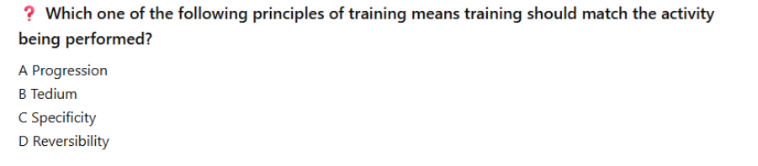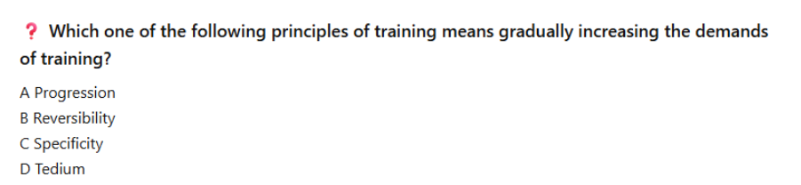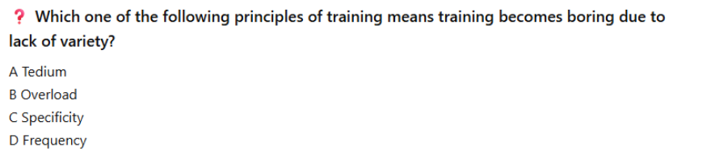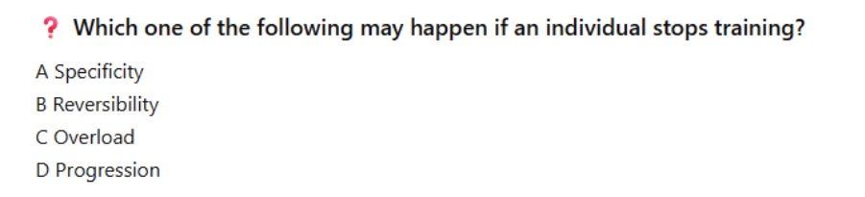
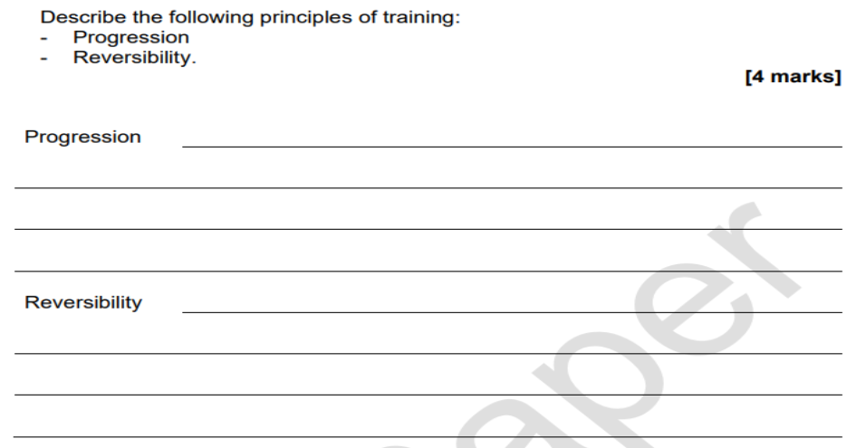

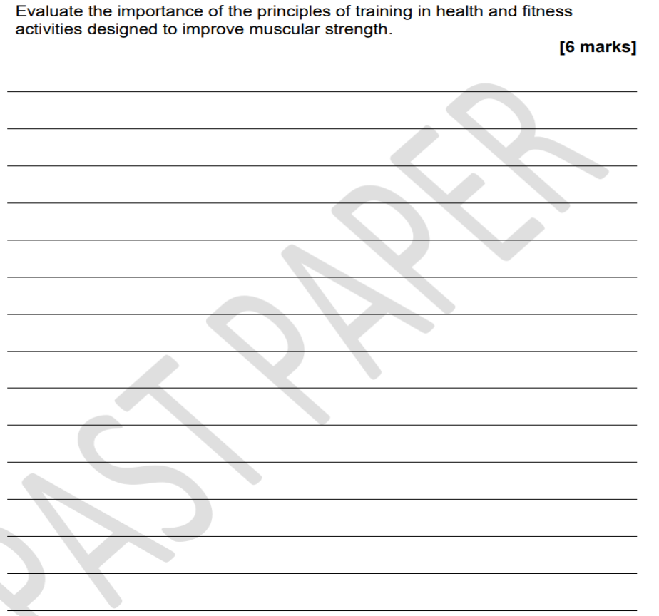
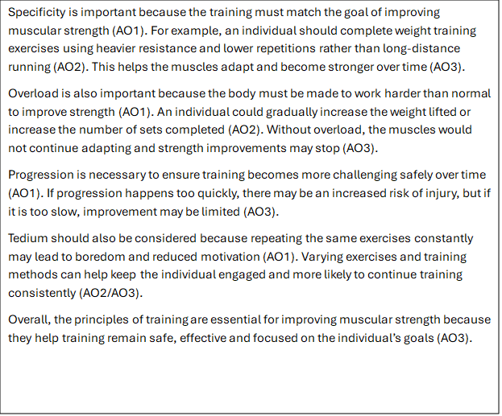

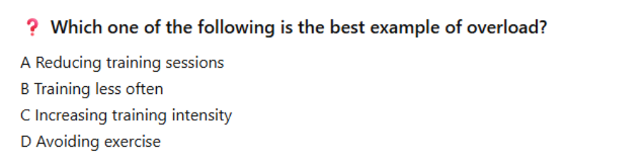
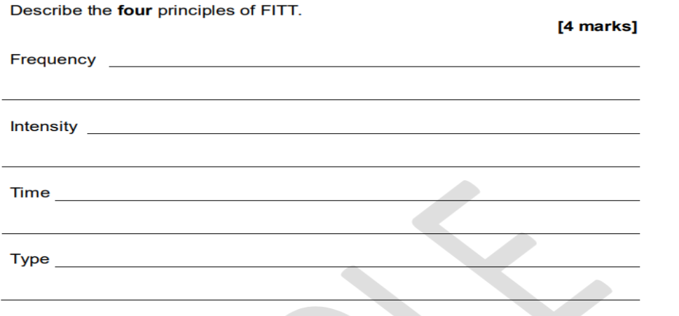
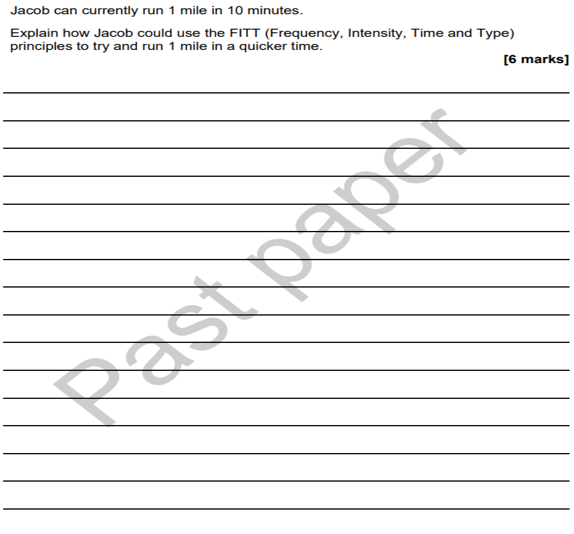
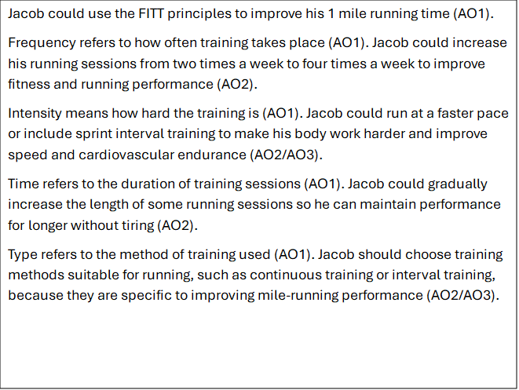
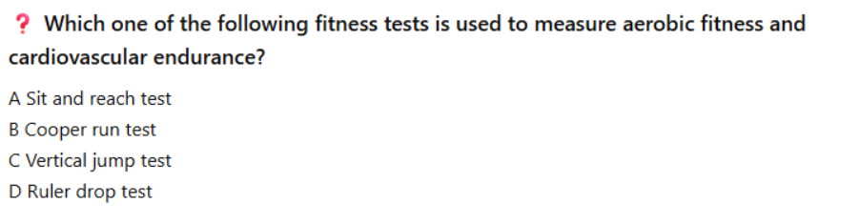
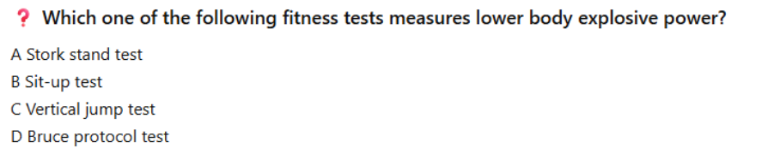
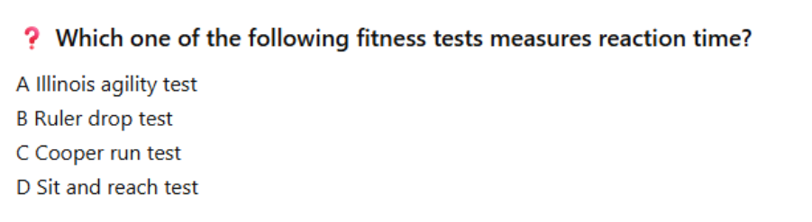
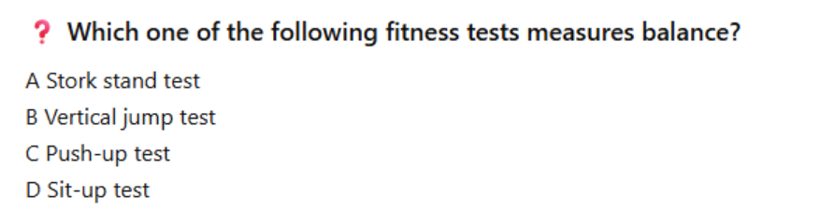
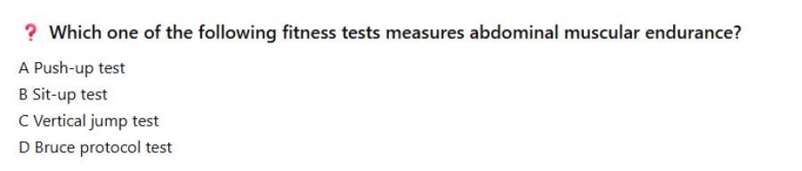
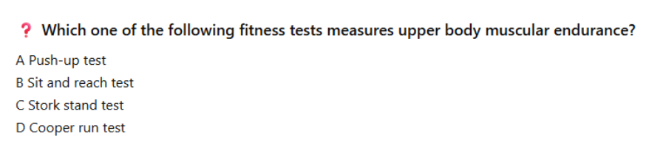
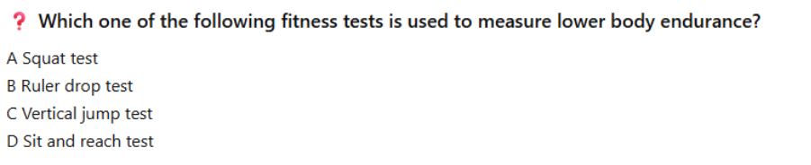
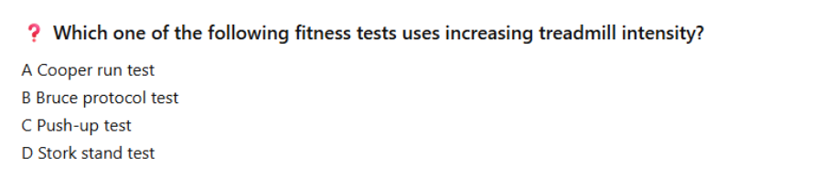
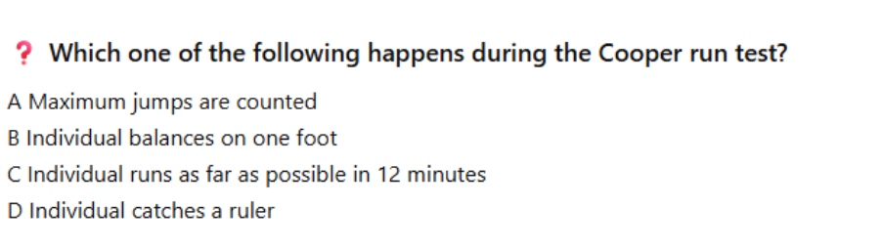
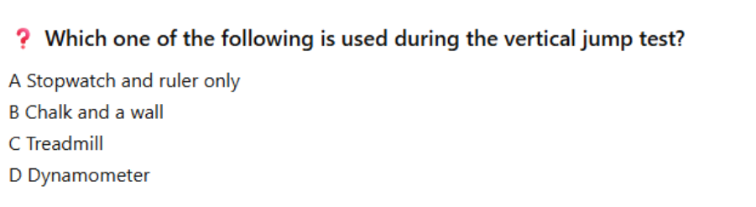
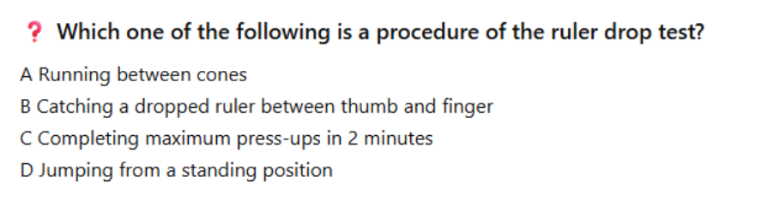
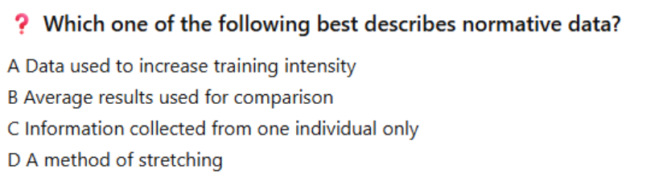
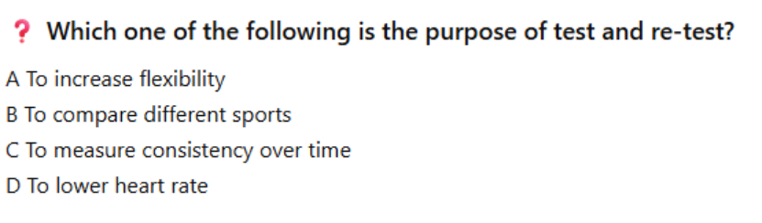
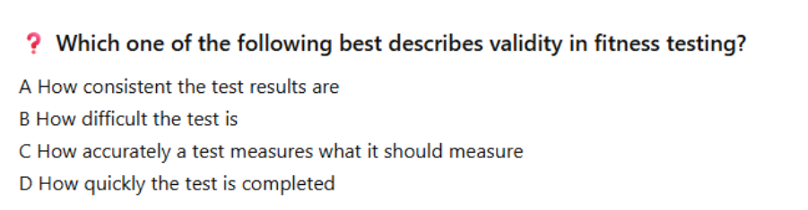
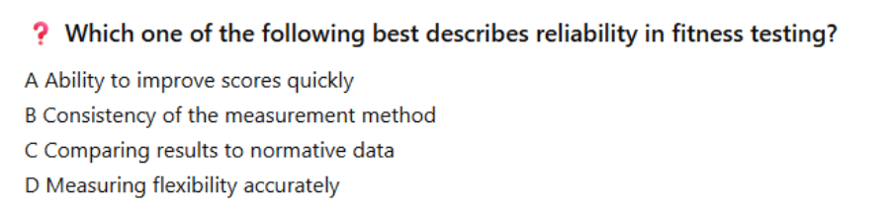
or results
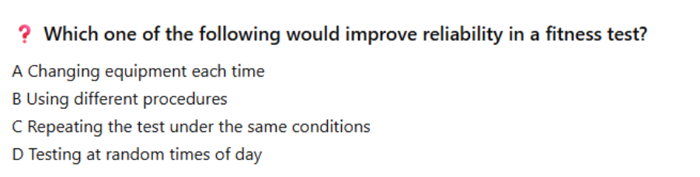

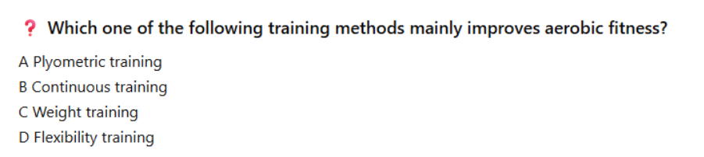
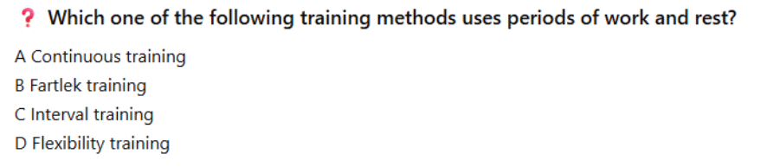
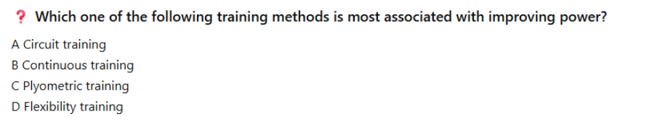
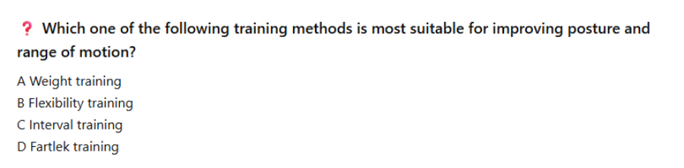
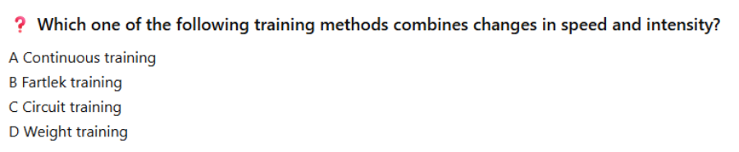
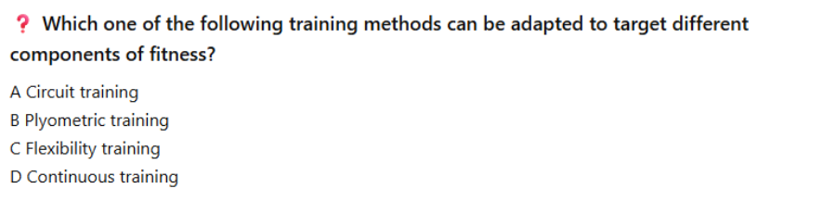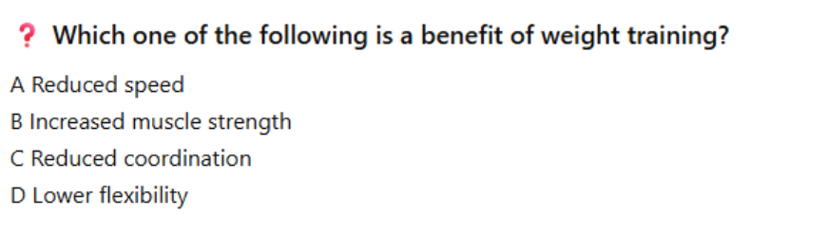
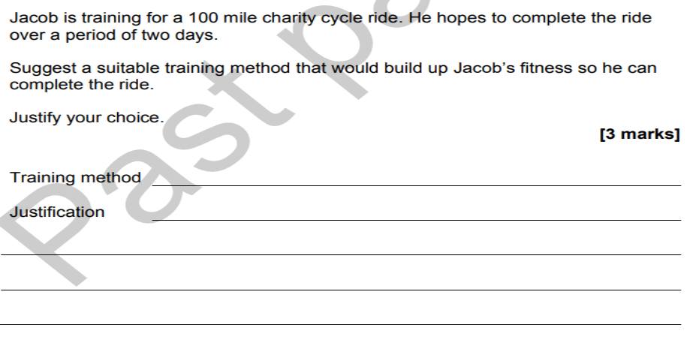
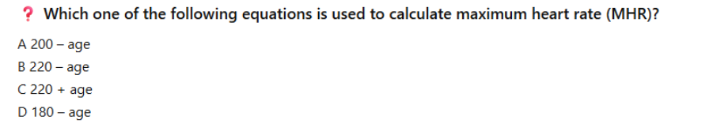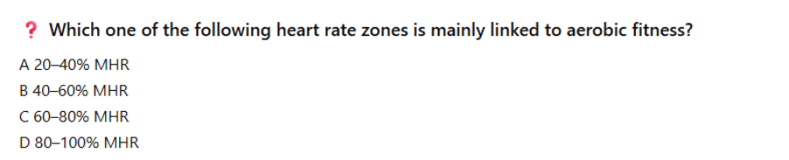
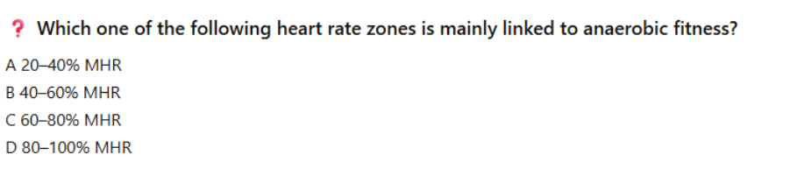
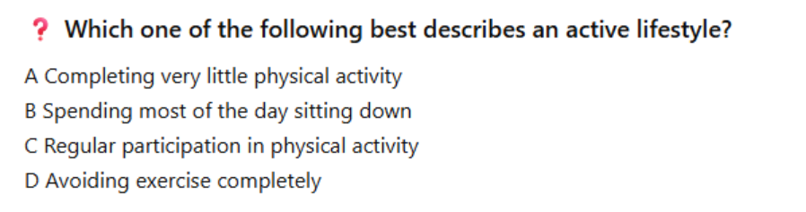
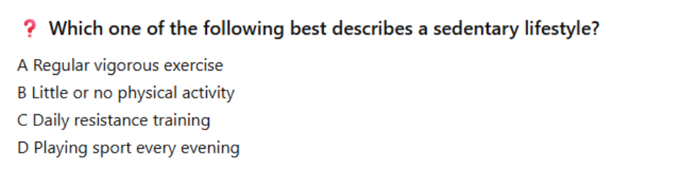
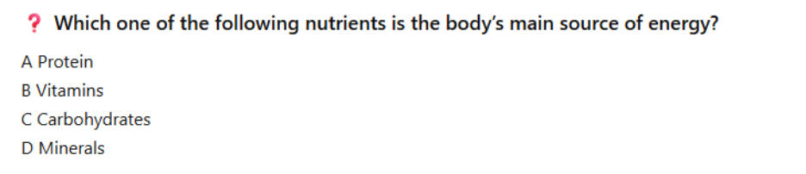
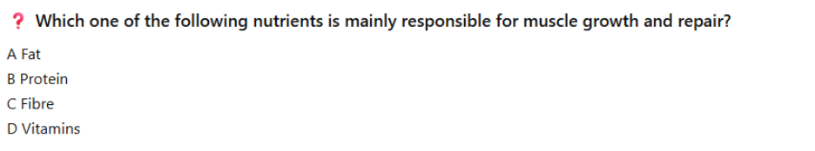
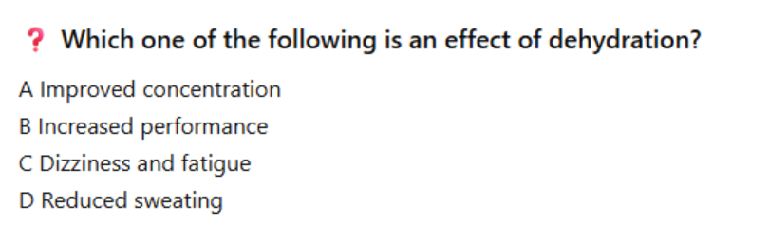
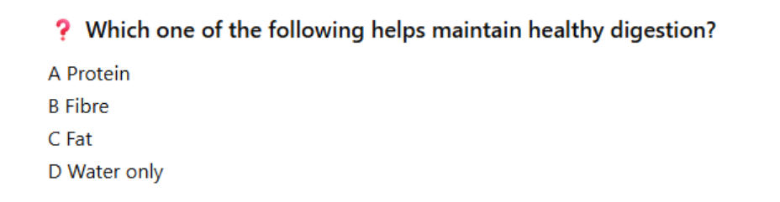

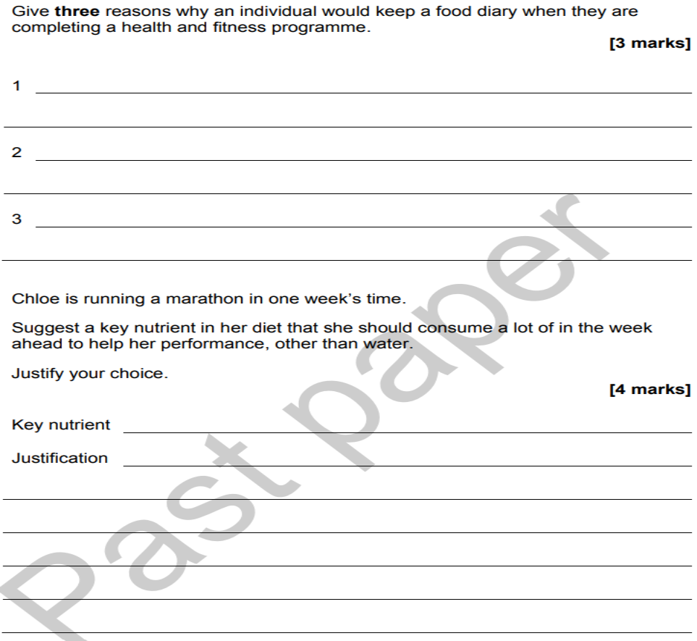

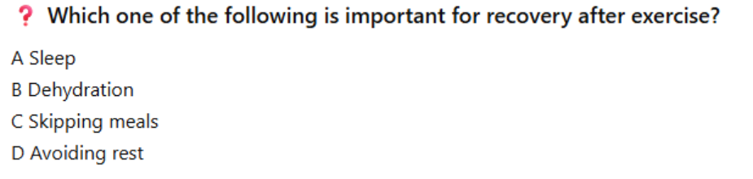
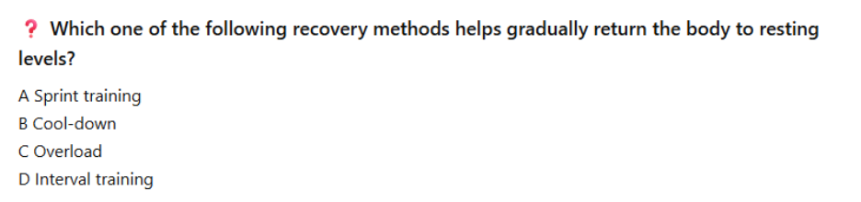
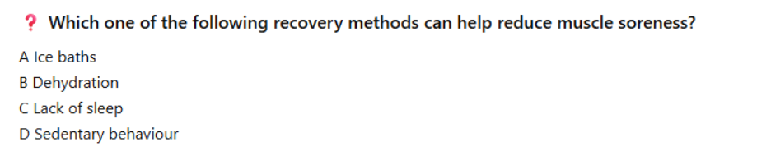
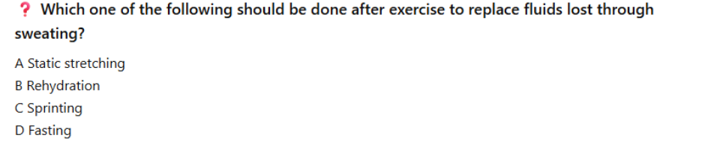
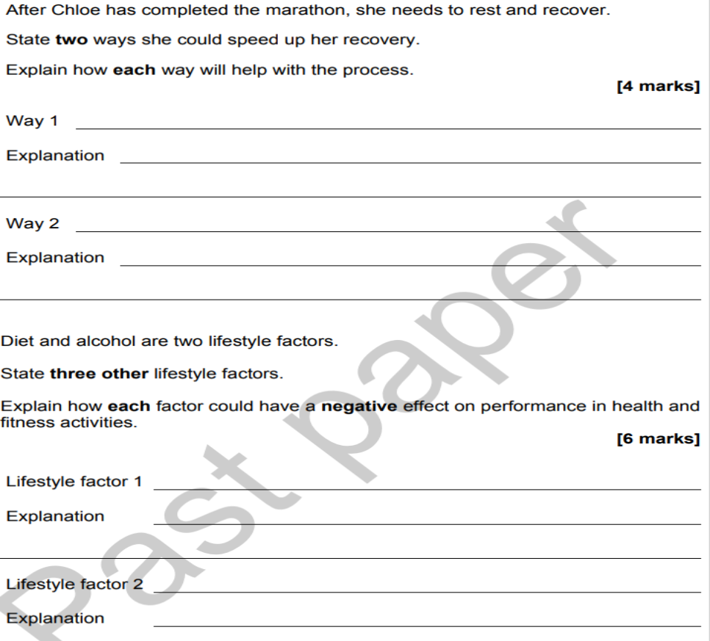

Rest & Recovery Methods =
- Sleep
- Diet & Rehydration
- Static Stretching
- Cool-down
- Ice Bath
- Massage
Way 1: Sleep 😴
Explanation: Sleep is important because the body carries out much of its repair and recovery during rest. Getting enough sleep can reduce fatigue and support muscle recovery after intense training.
Way 2: Diet and Rehydration 🍎💧
Explanation: Eating a balanced diet helps repair and rebuild muscle tissue, while carbohydrates replace energy stores used during exercise. Rehydration replaces fluids lost through sweating and helps prevent dehydration, preparing the body for future performance.
Way 3: Static Stretching 🤸
Explanation: Static stretching helps relax the muscles and improve flexibility after exercise, which may reduce muscle tightness and soreness.
Way 4: Cool-down 🚶
Explanation: A cool-down gradually lowers heart rate and helps remove waste products from the muscles, aiding recovery after exercise.
Way 5: Ice Bath 🧊
Explanation: Ice baths can help reduce swelling and muscle soreness after intense exercise, allowing the body to recover more quickly.
Way 6: Massage 💆
Explanation: Massage can increase blood flow to muscles and reduce muscle tension, helping muscles recover after activity.

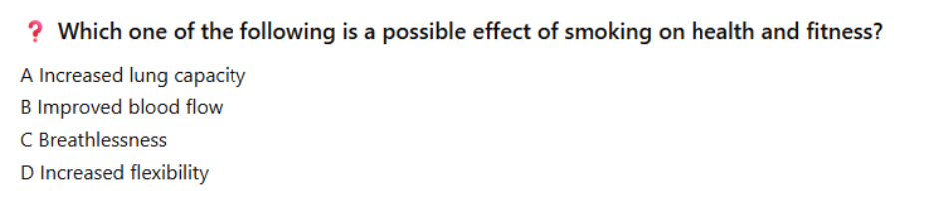
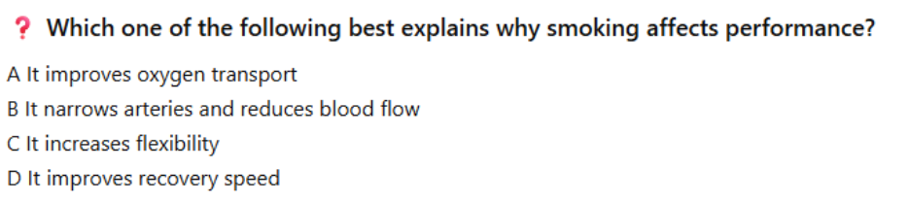
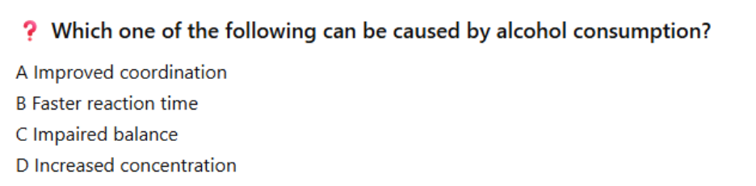
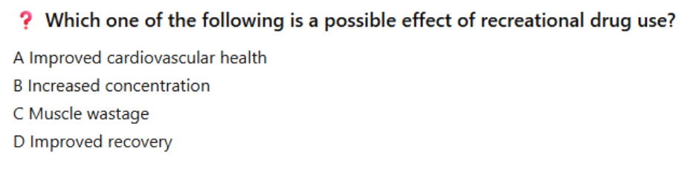
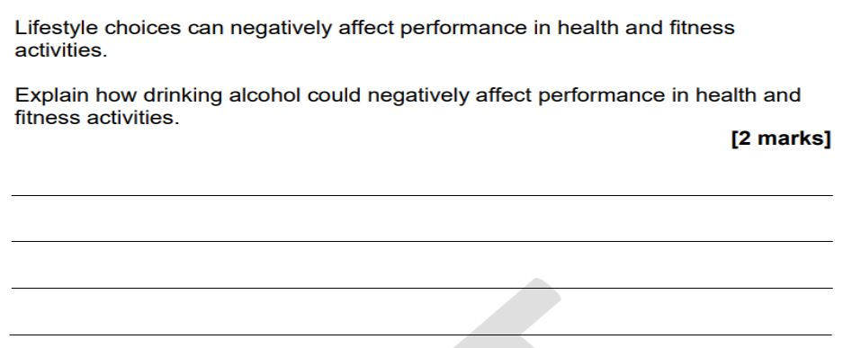

Negative Lifestyle Factors
🚬 Smoking
- Reduces lung capacity and oxygen delivery.
- Increases risk of heart disease, stroke and cancer.
- Causes breathlessness and poorer endurance.
🍺 Alcohol Consumption
- Can lead to dehydration.
- Slows reaction time and coordination.
- May cause weight gain and long-term liver damage.
🍔 Poor Diet
- Too much fat, sugar and salt can lead to obesity.
- Lack of nutrients can reduce energy levels and recovery.
- Increases risk of health conditions such as Type 2 Diabetes.
🛋️ Physical Inactivity (Sedentary Lifestyle)
- Increases risk of obesity and cardiovascular disease.
- Reduces fitness levels.
- Can negatively affect mental wellbeing.
😴 Lack of Sleep
- Causes fatigue and reduced concentration.
- Slows recovery from exercise.
- Can negatively affect mood and performance.
💧 Poor Hydration
- Leads to dehydration.
- Causes dizziness, headaches and fatigue.
- Reduces physical and mental performance.
💊 Drug Misuse (PED’s e.g. steroids/diuretics/ human growth hormone & Recreational Drugs e.g. cannabis, cocaine, ecstasy)
- Can damage organs and mental health.
- May affect judgement, coordination and performance.
- Increases risk of addiction and illness.
😟 Stress
- Can lead to anxiety and poor mental wellbeing.
- May affect sleep and motivation to exercise.
- Can increase blood pressure and heart rate over time.
What does PAR-Q stand for?

A. Physical Activity Recovery Questionnaire
B. Physical Activity Readiness Questionnaire
C. Personal Activity Readiness Quiz
D. Physical Assessment Recovery Quiz

What is the main purpose of a PAR-Q?

A. To measure fitness levels
B. To record food intake
C. To identify potential health risks before exercise
D. To set fitness targets

Which of the following would most likely be found on a PAR-Q?

A. Daily calorie intake
B. Favourite sport
C. Existing medical conditions
D. Fitness test scores

Which tool would provide information about a client's sleeping habits?

A. Food diary
B. Lifestyle questionnaire
C. Fitness test
D. PAR-Q

What information would a lifestyle questionnaire most likely collect?

A. Resting heart rate
B. Flexibility score
C. Alcohol consumption
D. Press-up score

Why is it useful to know a client's occupation?

A. It can indicate activity levels throughout the day
B. It shows their favourite exercises
C. It measures fitness levels
D. It predicts fitness test scores

Which analysis tool records what a client eats and drinks?

A. PAR-Q
B. Activity diary
C. Lifestyle questionnaire
D. Food diary
What information can be collected from a food diary?

A. Medical history only
B. Types of food consumed
C. Fitness test results
D. Blood pressure

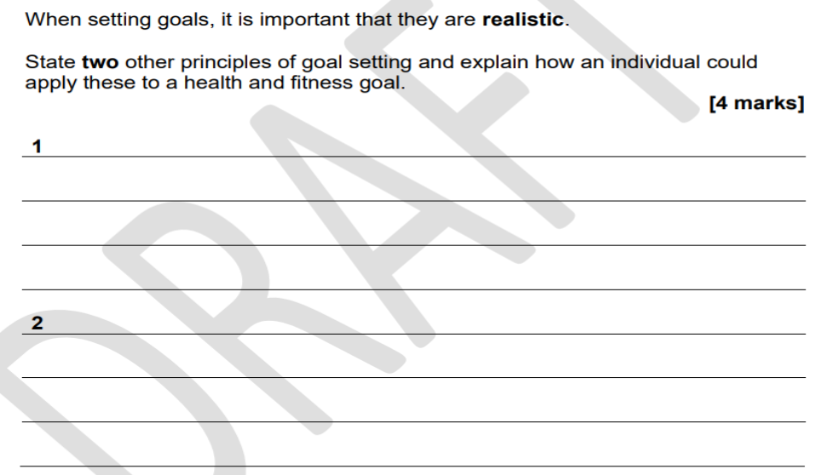

What is the main purpose of a warm-up?

A. To reduce flexibility
B. To prepare the body for exercise
C. To increase fatigue
D. To cool the muscles down

Which phase of a warm-up comes first?

A. Skill rehearsal
B. Stretching
C. Pulse raiser
D. Cool-down

What happens during the pulse raiser phase?

A. Heart rate gradually increases
B. Muscles cool down
C. Lactic acid is removed
D. Strength increases immediately

Which activity would be suitable for a pulse raiser?

A. Standing still
B. Slow jogging
C. Sleeping
D. Stretching only

Why is stretching included in a warm-up?

A. To decrease range of movement
B. To improve flexibility and prepare muscles for activity
C. To lower heart rate
D. To reduce motivation

Which type of stretching is most appropriate during a warm-up?

A. Static stretching
B. Dynamic stretching
C. Ice bath
D. Massage

What is the purpose of the mobilisation phase?

A. To increase the full range of movement at the joints
B. To lower body temperature
C. To remove lactic acid
D. To improve recovery

Which activity is an example of mobilisation?

A. Deep squat holds
B. Sleeping
C. Press-up test
D. Ice bath

What is the purpose of skill rehearsal?
A. To practise movements used in the activity
B. To lower heart rate
C. To improve recovery
D. To stretch muscles only

A football player practising short passes before a match is completing which phase?
A. Pulse raiser
B. Stretching
C. Skill rehearsal
D. Cool-down

What is the main purpose of a cool-down?
A. To prepare for exercise
B. To gradually return the body to its resting state
C. To increase intensity
D. To improve strength

What happens to heart rate during a cool-down?
A. It gradually decreases
B. It rapidly increases
C. It stays the same
D. It doubles

Which activity would be suitable during a cool-down?
A. Sprinting
B. Walking
C. Jump squats
D. Maximum press-ups

Why is stretching often included in a cool-down?
A. To improve recovery and reduce muscle tightness
B. To increase heart rate
C. To improve speed immediately
D. To increase body temperature

Which type of stretching is usually performed during a cool-down?
A. Dynamic stretching
B. Static stretching
C. Plyometric stretching
D. Ballistic stretching

What may happen if a performer does not cool down properly?
A. Improved recovery
B. Increased muscle soreness
C. Better flexibility
D. Increased energy stores

Put the warm-up phases in the correct order.
A. Stretching → Pulse Raiser → Skill Rehearsal → Mobilisation
B. Pulse Raiser → Mobilisation → Stretching → Skill Rehearsal
C. Pulse Raiser → Stretching → Mobilisation → Skill Rehearsal
D. Mobilisation → Pulse Raiser → Stretching → Skill Rehearsal



